The 11th China (Guangzhou) International Finance Expo

Service Manual

Catalogue
Preface 3
The Organizing Committee’s Office of GIFE Contact 4
Chapter 1 The 11th GIFE Exhibitors' Rights and Interests 5
Chapter 2 Notice to Exhibitors 11
Ⅰ. Exhibition Venue 11
Ⅱ. the implementation schedule 11
Ⅲ. the cloth and withdrawal of the exhibition schedule 11
Ⅳ. Document processing 11
Ⅴ. Related Provisions 13
Ⅵ.Health and epidemic prevention provisions 14
Ⅶ. the General Assembly designated supervision unit 16
Ⅷ. Guide to accommodation and transportation services 16
Ⅸ. Food Service Guide 16
Schedule 1 Food Service Reservation Form 17
Schedule 2 Business Travel Service Booking Form 18
Chapter 3 Standard booth set-up (withdrawal) exhibition instructions 21
I. Standard booth specifications and configuration 21
Ⅱ. modify the booth configuration and increase the exhibition equipment 21
Ⅲ. the cloth (withdrawal) exhibition notes 22
Exhibit 3 Post plus exhibition equipment rental application form - standard booth 23
Reference illustration of post-addition spreader 24
Chapter IV SPECIAL BOOTH set up (withdrawal) exhibition instructions 25
I. SPECIAL BOOTH contractor 25
Ⅱ. the GIFE green SPECIAL BOOTH initiative 25
Ⅲ. SPECIAL BOOTH drawings submitted for review process 27
Ⅳ. SPECIAL BOOTH of electricity to declare 28
V. Booth construction management regulations 28
Ⅵ. the exhibition notes 30
VII. Notes on the withdrawal of the exhibition 30
VIII. Deposit refund process 31
Ⅸ. the vehicle driving safety operation specification 31
Charges for SPECIAL BOOTH services 32
Schedule 4 Optional special arrangement construction unit responsibility commitment 33
Schedule 5 Booth Decoration Works Declaration Form - SPECIAL BOOTH 34
Schedule 6 SPECIAL BOOTH Construction Safety Responsibility Guarantee - SPECIAL BOOTH 35
Schedule 7 Electricity application form - SPECIAL BOOTH 36
Schedule 8 Booth Safety Electricity Responsibility Commitment – SPECIAL BOOTH 38
Schedule 9 Volume Control Commitment - SPECIAL BOOTH 39
Schedule 10 Communication and Multimedia Services Application Form 40
SPECIAL BOOTH diagram 42
Chapter 5 Exhibition Hall Management Regulations 43
List of procedures and precautions related to the exhibition 53

Preface

Exhibitors.
Welcome to the 11th China (Guangzhou) International Finance Expo (hereinafter referred to as GIFE).
In order to provide exhibitors with fast and considerate services and ensure the success of the conference, the Organizing Committee’s Office of GIFE has formulated this Service Manual, which exhibitors are requested to read through carefully in order to familiarize themselves with the exhibition procedures and make preparations for the exhibition in advance.
In order to ensure the smooth setup, exhibition and withdrawal of each exhibitor, please fill in the relevant forms in this manual according to your actual needs and upload them to the exhibitor system, fax them or send them back to the Organizing Committee’s Office of GIFE before the specified deadline according to the contact information in the form.
All exhibitors participating in this exhibition shall strictly abide by the Service Manual of the 11th China (Guangzhou) International Finance Expo and the relevant regulations of the China Import and Export Fair Complex, and each exhibitor is requested to carefully implement the regulations set forth in this manual.
If your organization needs further assistance, please contact directly with the Organizing Committee’s Office of GIFE or the conference supervisory unit; during the exhibition, please contact with the service points on the conference site.
The right of interpretation of this manual belongs to the Organizing Committee’s Office of GIFE.

The Organizing Committee’s Office of GIFE
May 2022

China (Guangzhou) International Financial Exchange - Expo Organizing Committee Office Contact Information
(During the exhibition, the phone number is common)
Responsible for work | Specific matters | Contact person | Phone
Exhibitor Services | General Manager of Exhibitors | Huang Xun | 020-83385852
 | 2.2 Pavilion | Xiao Donglin | 020-83399898
 | 3.2 Pavilion | Yuan Yongkang | 020-83393892
 | 4.2 Pavilion | Fan Ruiying | 020-83343042
 | 5.2 Pavilion | Xiao Zijun | 020- 83197883
Forum Summit | Forum Cooperation | Xiao Zijun | 020- 83197883
 | Registration | Zou Qing | 020-83198003
Brand Events | Industry and Finance Integration | Yuan Yongkang | 020-83393892
 | Financial Services for Rural Revitalization | Xiao Donglin | 020-83399898
 | Roadshow special event for companies to be listed | Xiao Donglin | 020-83399898
 | Financial book "Golden Ram Award" | Lin Longyong | 13828417758
 | Guangzhou Financial Release | Zhang Shendi | 020-83311818
 | Lingnan Financial Culture Ambassador Selection Contest | Li Wan Ling | 020-83385382
 | Guangdong financial industry "I do practical things for the masses" practice results show | Li Wan Ling | 020-83385382
 | "Red financial culture under the leadership of the Communist Party of China" special exhibition area | Su Huiying | 020-83029306
 | Lingnan Finance Festival | Xiao Donglin | 020-83399898
News | Press Contact | Zhang Shendi | 020-83311818
Exhibition order coordination | Security Issues | Tang Yong | 18665098066
 | Noise Control | Huang Jun | 13929545699
 | Legal Mediation | Wu Le | 18002216932
Build Services | Standard Booth | Huang Jun | 13929545699
 | Special Booth | Wei Yingxu | 13430319199
Business Travel Services | Accommodation, transportation | Yuxi Zhao | 18202682219
GZIFE Investment Management Co.Ltd.
Address: 3rd Floor, Building 8, Hotel Canton, 374 Beijing Road, Yuexiu District, Guangzhou, 510030, China
Fax: 020-83186940
Email: gzife@gzife.com
Official website: www.gzife.com

Chapter 1 The 11th GIFE exhibitors' rights and interests

Thank you for your support and participation in the 11th China (Guangzhou) International Finance Expo (hereinafter referred to as "GIFE").
I. Conference Publications
Please log in to the exhibitor system, fill in the "Corporate Profile Form" and upload the vector image of the LOGO and the QR code of WeChat and Weibo (to ensure the image can be uploaded correctly, only JPG or PNG format images will be accepted. ). If there are several joint exhibitors in one booth, each organization can register and provide information individually. Please provide no more than 6 abbreviations in Chinese characters, e.g. "Guangzhou Industrial Investment" for Guangzhou Industrial Investment and Capital Operation Holding Group Ltd.
Ⅱ. Industry and Finance Integration
The GIFE actively promotes the matchmaking of major financing and cooperation projects and the cooperation between the government and financial institutions, between financial institutions and financial institutions, and between financial institutions and enterprises. By holding a signing ceremony for major projects, signing credit agreements and letters of intent; building a project exhibition platform and holding project roadshows; holding project matching seminars and promoting a new project matching mechanism of "precise matching and intent negotiation", the two parties can negotiate directly, and promote the transaction on the GIFE platform. to reach a deal. Please login to the exhibitor system, fill in and submit the "Industry-Financial Matching Project Statistics Form" and "Project Matching Statistics Form", and the major projects will be selected and sent to the Industry-Financial Matching Signing Ceremony after the audit.
Ⅲ. Awarding Ceremony
The GIFE is an important time point and platform to review the achievements of financial reform and innovation and scientific development in a focused manner. The launching ceremony will focus on the awarding ceremony for the newly established financial institutions and platforms of the year. Please login to the exhibitor system and fill in the "Awarding Information Statistics Form", which will be selected and sent to the General Assembly for the awarding ceremony of new financial institutions and platforms after audit.
Ⅳ. Lingnan Financial Festival
Exhibitors and exhibits and related activities held during the conference can be reflected in the official website of the conference, official WeChat and other communication channels, and some of them can get key publicity and promotion opportunities.
- Product promotion activities
The exhibitors' financial products and preferential policies launched during the exhibition will be published on the promotional materials of the 11th GIFE after approval. Exhibitors are requested to propose "one sentence" preferential content (multiple preferential content can be filled in), which can be special products and financial services for enterprises and citizens, etc. Please log in the exhibitor system, complete and submit "Information Form of Preferential Activities", exhibitors must ensure that the content of the preferential activities is accurate, true, valid and legal; ensure that The goods or services involved in the preferential activities meet the relevant national requirements; at the same time, in order to regulate the on-site transactions of the conference, institutions are requested to submit samples of promotional leaflets (electronic version) planned to be distributed on site.
- Roadshow, promotion activities
Exhibitors will be given priority to apply for the use of the conference venue for roadshows, presentations and other on-site activities (the content needs to be reviewed by the organizing committee, please contact the organizing committee staff for details).
- Information dissemination activities
Exhibitors who need to release information about new projects, new cooperation and new achievements can apply to use the conference venue to hold a conference (the content needs to be reviewed by the organizing committee, please contact the organizing committee staff for details).
- Booth activities
In order to better guide visitors to participate in each exhibitor's on-site activities, the Organizing Committee will incorporate the financial knowledge seminars and live performances held by exhibitors at their on-site booths into the Financial Festival series. Exhibitors are requested to log into the exhibitor system, fill in and submit the "Organizational Activity Information Form", including the time, location, content and relevant details of the activities. After approved by the Organizing Committee, the form will be published on the promotional materials of the 11th GIFE Conference. (Exhibitors must ensure that the content of the event is accurate, true, valid and legal; and that the goods or services involved in the event meet the relevant national requirements)
- Cloud shopping exhibition brand exposure
The organizing committee organizes the media cloud to stroll around the exhibition, visit the exhibition hall of the organization, and reveal the brand image of the organization. (For details, please contact the organizing committee staff)
Ⅴ. Exhibit Documents
Exhibitors' admission documents will be issued according to the actual number of applications (the standard number of documents to be issued is 6 standard booths/18㎡; 2 special booths/9㎡, the maximum number of applications per organization is 50).
Ⅵ. Invitation Tickets
The GIFE welcomes exhibitors to actively initiate invitations, and invitations to the conference will be allotted according to the needs of each exhibitor. To submit the number of tickets, please log into the exhibitor system and fill in the number of tickets section in the Exhibitor ID Application Form.
Ⅶ. Participation in Forum Meetings
Exhibitors will be given priority to participate in the GIFE series of forums and conferences (see the forum poster for registration).
Ⅷ. Commemorative Materials of the General Assembly
Exhibitors can get the GIFE commemorative album and forum anthology from the conference.
Ⅸ. A Series of Brand Activities
As a regional financial culture card, the annual financial book "Golden Sheep Award" and Lingnan financial culture ambassador activities, exhibitors are invited to participate in the construction of Guangdong's financial culture, create a good environment for the development of the financial industry and cultural atmosphere, shaping the brand image of Lingnan financial culture, and enhance the soft power of Guangdong's financial culture.
Ⅹ. Multi-channel Communication and Promotion
Multi-channel distribution of excellent materials, exhibitors provide high-quality promotional materials, you can get key publicity and promotion opportunities.
Ⅺ. List of Exhibitors' Rights and Interests
Serial number | Rights and interests | Application Deadline | Remarks
1 | Signing the Exhibitor Contract | May 15 | Required field
2 | Conference Publication "Corporate Profile Form | May 31 | Required field
3 | Industry and Finance Integration  1. Statistical Table of Industry and Finance Integration Projects  2. Project Matching Statistics Form | May 31 | Optional
4 | Awarding Ceremony "Awarding Information Statistical Form | May 31 | Optional
5 | Lingnan Finance Festival  Information Sheet on Preferential Activities  Information Sheet on Institutional Activities | May 31 | Optional
6 | Exhibiting Documents "Exhibiting Documents Application Form | June 6 | Real name application
7 | Invitation Tickets "Application for Exhibitor's Documents | June 6 | On-demand application
8 | Register to participate in the forum (the schedule is updated on the official website / official microblog) | June 6 | Separate Registration
9 | General Assembly Commemorative Materials | After the meeting | Return Mailing
10 | Participate in a series of branding events | Held annually | Separate notification
Ⅻ. Return of Exhibitors' Rights and Interests
In order to ensure the rights and interests of exhibitors, the Organizing Committee will open an independent exhibitor system for each exhibitor. After signing the Exhibitor Contract, the staff of the Organizing Committee will open the system and inform you the login name and password in time. Exhibitors are requested to log in to the exhibitor system under "exhibitors" on the official website (www.gzife.com) and submit their applications by clicking on the corresponding forms in the system. Please read the Service Manual carefully to ensure smooth participation.

Annexes
GIFE Exhibitor Access Methods
I. Domestic institutions
1、Basic guidelines
(1) Business license
Exhibitors must have and provide the original business license with unified social credit code to the Organizing Committee of GIFE for verification, and provide relevant copies to the Organizing Committee of GIFE for record and archive.
(2) Compliance with laws, regulations and policies
Accounting Law", "Anti-Money Laundering Law of the People's Republic of China", "Regulations on the Administration of Futures Trading", "Guidance of the China Banking Regulatory Commission on the Financial Services for Small and Micro Enterprises in 2015", "Guidance of the China Banking Regulatory Commission on Further Promoting the Healthy Development of Village Banks", "Notice of the China Banking Regulatory Commission on Improving and Innovating Loan Services for Small and Micro Enterprises to Improve the Financial Services for Small and Micro Enterprises". Measures for the Administration of Network Payment Business of Non-Bank Payment Institutions" "Implementation Plan for the Special Rectification of Internet Financial Risks Investment and financial management in the name of financial activities risk special rectification work to implement the implementation of the special rectification work implementation plan" "Guangzhou City, the provisions of the exhibition and sale" "the State Council on the clean-up and rectification of various trading venues to effectively prevent financial risks" (State Council issued [2011] No. 38) "the General Office of the State Council on the clean-up and rectification of various trading venues implementation opinions" (State Office issued [2012] No. 37) and other relevant Laws and regulations, policy provisions.
2、The principle of admission screening for exhibitors
(1) "One line, two bureaus" regulatory agencies
Current and valid licensed financial institutions registered with the People's Bank of China, the China Banking and Insurance Regulatory Commission and the China Securities Regulatory Commission may exhibit directly. Existing members registered with the China Banking Association, China Securities Association, China Insurance Association, China Securities Investment Fund Association, China Listed Companies Association, China Futures Association, China Payment and Settlement Association, China Trust Association, China Finance Companies Association and China Microfinance Companies Association may exhibit directly.
(3) Co-organizer member institutions
Association, Guangdong Financial Leasing Association, Guangdong Commercial Factoring Association, Guangdong Financial Guarantee Association, Guangdong E-Commerce Investment and Financing Association, Guangzhou Financial Industry Association, Guangzhou Financial Talents Association, Guangzhou Digital Finance Association, Guangzhou Green Finance Association, Guangzhou Microfinance Industry Association, Guangzhou Private Equity Association, Guangzhou Venture Capital Association, Guangzhou Commercial Factoring Industry Association, Guangzhou Guangzhou Financial Leasing Industry Alliance, Guangzhou Federation of Industrial Economics, Guangzhou Federation of Enterprises, Guangzhou Entrepreneurs Association, Guangzhou New Third Board Enterprises Association registered members or recommended exhibitors can exhibit directly.
(4) business, association member institutions
Member organizations of business and association units that have been evaluated by national social organizations with a grade of 3A or higher can exhibit directly.
(5) Other domestic institutions
Other domestic institutions that are not listed in items 1-4 above must fully comply with the following conditions in order to exhibit.
a. Year of establishment of the institution
From the date of issuance of business license to the audit date of the GIFE Organizing Committee, the company must be established (on-line) for a period of (including) one year. In case of special circumstances, it can be relaxed to its parent company established for a full (inclusive) year upon written approval of the Organizing Committee of the GIFE.
b. Institutional registered capital
The minimum registered capital of the exhibitor is (including) 5 million RMB, and the paid-up registered capital accounts for more than one-fourth of the pledged registered capital (including).
c. Network Exclusion
(a) National Enterprise Credit Information Public Notice System
Exhibitors are required to be listed in the National Enterprise Credit Information Publicity System (URL: http://www.gsxt.gov.cn/index.html) and have been ranked and have no bad information.
(b) National Court Executed Person Information Search System
Exhibitors are required to be ranked and have no bad records in the National Court Executed Persons Information Search System (URL: http://zhixing.court.gov.cn/search/).
(c)Tianwei Check Network Inquiry System
Exhibitors are required to check the network query system (URL: http://www.tianyancha.com/) in the sky-eye check and have no bad information after ranking.
(d) Online information
Exhibitors may not have more than 30 complaints within the online search system within the last year.
II. Overseas institutions
1、Basic guidelines
(1) Hong Kong, Macao and Taiwan exhibitors
Exhibitors must comply with laws, regulations and policies including, but not limited to, the Mainland and Hong Kong Closer Economic Partnership Arrangement and related supplementary agreements (Hong Kong region), the Mainland and Macao Closer Economic Partnership Arrangement and related supplementary agreements (Macao region), and the Cross-Straits Economic Cooperation Framework Agreement and its Annexes (Taiwan region).
(2) Other foreign exhibitors
a. If the exhibitor belongs to a WTO member country/region, the relevant WTO rules will apply and must comply with them, including but not limited to the Financial Services Agreement [Note: i.e. the Fifth Protocol to the General Agreement on Trade in Services], etc.
b. Exhibitors belonging to non-WTO member countries/regions must comply with the applicable treaties signed between China and the country/region; if China has not signed the relevant treaties with the country/region, public international law will apply.
2、The principle of admission screening for exhibitors
(1) Overseas government regulators
Organizations that have exhibited in concert with government-type agencies such as the Hong Kong Monetary Authority, Hong Kong Monetary Development Council, Hong Kong Trade Development Council, Macau Monetary Authority, Japan External Trade Organization, Korea Trade-Investment Promotion Corporation, Malaysian Investment Development Authority, Australian Trade Commission, etc. may exhibit directly, except where national or provincial or municipal policies have restrictions.
(2) Foreign businessmen, association member institutions
Existing members registered with the British China Trade Association, the American Chamber of Commerce in South China, the British Chamber of Commerce in Guangdong, the Spanish Chamber of Commerce in China, the Australian Chamber of Commerce in China, the French Chamber of Commerce and Industry in China, and the Australian China Business Council may exhibit directly, except where national or provincial policies have restrictions.
(3) Other foreign institutions
Other foreign institutions that are not listed in items 1 and 2 above must fully comply with all of the following conditions in order to exhibit: they must have the regulatory mark of the corresponding region, provide the original registration license of the relevant place to the organizing committee of the GIFE for verification and approval, and provide relevant copies to the organizing committee of the GIFE for record and archive; if they have subsidiaries, branches or other related institutions in China, the company and its subsidiaries, branches and If there are subsidiaries, branches or other related organizations in China, the company and its subsidiaries, branches and other related organizations shall follow these measures.
3、The content of the exhibition of foreign exhibitors can be used for image display and promotion, but no substantive business can be concluded on site.
III. Other provisions
1. Exhibitors must unconditionally accept the inspection and supervision of the Organizing Committee of GIFE and comply with other regulations made by the Organizing Committee of GIFE.
2. exhibitors shall not engage in the following negative list of businesses, specifically: (1) absorbing or disguising public deposits, organizing or participating in any name or form of fund-raising activities; (2) issuing or entrusted to issue loans, except for microfinance companies; (3) to carry out notes, trust products, trust income rights, private securities, private fund shares, asset securitization products, insurance asset transactions (with the central (except for the approval of the financial regulatory authorities); (4) to carry out payment and settlement business; (5) to carry out business or activities prohibited by laws and regulations; (6) the relevant regulatory authorities do not consider it appropriate to carry out the test at present.
3. The organizing committee of the GIFE is responsible for the revision and interpretation of these measures. If there is any revision of these measures, an announcement will be made on the official website of the GIFE (URL: www.gzife.com) without further notice.
4. this method is officially implemented from February 8, 2018 and revised on March 31, 2022.

Chapter 2 Notice for Exhibitors

I. Exhibition Venue
No. 382, Read River Middle Road, Haizhu District, Guangzhou City, Guangdong Province, China
Hall 2.2, Hall 3.2, Hall 4.2, Hall 5.2, Zone A, China Import and Export Fair Pazhou Complex

Ⅱ. the implementation schedule
Conduct time |  | Exhibitors | Audience
June 24 | Entry time | 08:30 | 09:30
 | Stop entry time | 16:30 | 16:30
 | Clearance time | 17:00 | 17:00
June 25 | Entry time | 09:00 | 09:30
 | Stop entry time | 16:30 | 16:30
 | Clearance time | 17:00 | 17:00
June 26th | Entry time | 09:00 | 09:30
 | Stop entry time | 15:30 | 15:30
 | Clearance time | 16:00 | 16:00
*Close entry period, you cannot re-enter the pavilion after exiting.

Ⅲ. the cloth withdrawal schedule
Layout time | Specially decorated booths | Standard Booth
 | June 21-23 9:00-17:00 | June 22nd 13:00-17:00  June 23rd 9:00-17:00
Withdrawal time | June 26, 16:00-20:00

Ⅳ. Document processing
(A) Exhibitor's card: Exhibitors' admission documents will be issued according to the actual number of applications (standard number of exhibitors: 6 standard booths/18 square meters; 2 special booths/9 square meters, the maximum number of exhibitors per organization is 50).
Exhibitor Pass Usage Period: June 21-26, 2022 from 9:00-17:00 (June 24 from 8:30-17:00)

(B) the preparation (withdrawal) of the exhibition personnel card, car card.
The Canton Fair Complex implements a real-name appointment system for the preparation and withdrawal of exhibition personnel and trucks for permits and truck time checks for daily exhibitions. During the preparation and withdrawal of the exhibition engaged in booth installation, cargo transportation / loading and unloading, equipment installation and other related operations personnel and trucks are required to apply for the preparation and withdrawal of the exhibition construction personnel pass or preparation and withdrawal of the exhibition vehicle permit. Lost documents will not be replaced.
- Document processing methods and processes.
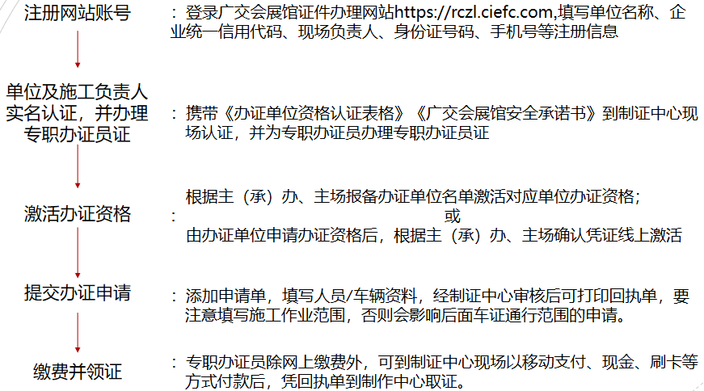
(1) the registration of the qualification of the licensing unit and the licensing process.
(2) Set up the card office.
Canton Fair Complex Area A: Counter 6-1,6-2, Pearl River Promenade.
Canton Fair Complex Area B: Exhibit Hall East card-making point. Metro Pazhou Exit A (Canton Fair Overseas Buyer Check-in)
Canton Fair Complex Area C: Hall 16.1 (Canton Fair Overseas Buyers' Check-in)
(3) Carding time: The process will start 7 days before the entrance (i.e. June 14). The working hours of the card office are from 9:00 a.m. to 6:00 p.m.
- Prepare for and withdraw from the exhibition staff pass.
(1) Object of use: During the exhibition preparation and withdrawal, people who need to enter the pavilion to engage in booth installation, cargo transportation/loading, equipment installation, etc. need to apply for the pass. The pass is for personal use only and will not be allowed for related operations without the pass.
(2) Fee: 40 yuan per certificate. In addition, each card is complimentary 10 yuan personal accident insurance premium.
- Prepare and withdraw the exhibition van documents.
(1) the use of objects: in the exhibition during the preparation and withdrawal of the exhibition to transport loaded materials, exhibits and equipment to and from the exhibition hall of freight vehicles. The document is limited to the use of this vehicle with a permit.
(2) Charges: 50 yuan per vehicle per certificate /, deposit of 300 yuan.
(3) document validity and deposit refund: vehicles in the validity of the car card every time through the entrance and exit verification timing points as a timing closed loop, leaving the timing area after the car card is invalid. Each time the vehicle enters the timing area free parking time of 150 minutes, overtime every 30 minutes (included) will be deducted from the car card deposit of 50 yuan, deducted until the end. If the vehicle in and out of the exhibition preparation and withdrawal time inversion or in and out of time data is incomplete, the deposit for the card will not be refunded. If the vehicle is not parked over time, the deposit will be returned from the original payment channel within three working days after the end of the exhibition. According to the principle of "one exhibition hall, one vehicle, one certificate", more than one pavilion operations need to apply for multiple documents.
(3) Inbound voucher: In order to avoid disruption of the exhibition site by organizations without exhibitor qualification distributing leaflets, exhibitors are required to bring in promotional materials from outside the exhibition hall during the exhibition period with the inbound voucher. It is recommended that exhibitors apply for the incoming goods voucher (for entry into the exhibition hall) together with their exhibitor documents. During the exhibition period, the replenishment vehicle must have a truck permit to enter the exhibition hall. For emergency replenishment, please contact Huang Jun: 13929545699 for replenishment.
(4) Release Slip: issued at the service point on site during the exhibition, with the release slip (for exit) to transport or take out exhibits from the exhibition hall.
Processing hours: 21 - 23 June 2022 9:00 - 17:00.
June 26, 2022 16:00-20:00.

Ⅴ. Related Provisions
(A) the management of promotional materials regulations
Without the permission of the Organizing Committee of the GIFE, no unit or individual shall use the name of China (Guangzhou) International Financial Exchange - Expo to solicit external exhibitions and manuscripts, advertisements, or use the words "China (Guangzhou) International Financial Exchange - Expo" in Chinese or English (including its abbreviated characters) on the front and back covers of any publications and promotional materials. The logo of the conference shall not be used either.
(B) booth use management regulations
All exhibitors and exhibitors should have the business license of the enterprise legal person (a copy of which must be brought during the exhibition for on-site inspection by the relevant departments), strictly abide by the exhibition management regulations and shall not use the booth illegally.
1. Criteria for determining the use of booths in violation (including but not limited to)
(1) External publicity in the name of non-exhibiting companies.
(2) Distribute business cards with non-exhibitor names in the booth.
(3) Distributing leaflets and parading with signs within the exhibition hall and not in their own booths.
(4) Transferring, sublicensing, subcontracting or subleasing the use of the booth in any other way to a third party that is not an exhibitor.
(5) Exhibitors charging third parties other fees in excess of normal booth costs.
(6) Other irregularities in the transfer or subletting (sale) of booths as confirmed by the Organizing Committee.
(7) exhibitors whose exhibited products, scope of services, and exhibiting activities do not comply with the relevant laws and regulations, policy provisions and other relevant provisions of the exhibition, and who are not qualified to operate products commercially.
(8) Exhibitors' booths are engaged in any activities that are not related to the show, prohibited by the show, or otherwise illegal.
(9) exhibitors do not follow the principles of fairness, impartiality, honesty and credit to carry out the commercial operation of financial products / service activities.
2、The units that violate the use of booths will be handled as follows.
(1) Clearance of the offending booths during the closing period of the day.
(2) confiscate the relevant exhibition documents.
(3) If the booth is transferred or sublet (sold) in violation of the law, the exhibitor will be disqualified from participating in the exhibition for five consecutive sessions from the current session, and will be recorded in the violation list.
(C) the order of the exhibition hall regulations
1、Small cars and vans are not allowed to enter the exhibition hall to unload goods.
2. Food hygiene and safety regulations of the exhibition hall, all take-away food is not allowed in the exhibition hall.
3. Exhibitors may only distribute leaflets in their booths, not in the aisles of the exhibition hall.
4. Exhibitors are not allowed to bang gongs and drums in the aisles or parade with signs in the exhibition hall.
5. In order to create a good trading environment, the volume of each booth must be controlled within 70 decibels; booths in the main venue pavilion area are completely silent, and the installation of any form of audio equipment and speakers in the booth is strictly prohibited.
6. With the consent of the Organizing Committee, the booth can be designed and decorated according to actual needs, but it must comply with the Organizing Committee, the exhibition hall and the provisions of relevant laws, regulations and policies. Exhibitors shall be liable for damages caused by improper installation and removal of exhibits to the facilities of the venue.
7. Exhibitors shall remove their exhibits, exhibits and materials and bear the transportation costs during the specified period after the show. If exhibits, exhibits, materials, etc. are abandoned at the exhibition hall site, the exhibitor shall bear the cost of removal or disposal, and shall compensate for the resulting loss and delay.
8、Exhibitors should complete the booth construction and arrangement before 17:00 on the day before the opening of the exhibition.
9、Exhibitors shall ensure the safety of on-site construction and dismantling, and if accidents (including but not limited to property damage, casualties, etc.) occur due to construction and dismantling, exhibitors shall bear all responsibilities.

Ⅵ. Health and Epidemic Prevention Provisions
(a) All people entering the venue are required to register by real name, wear a mask, present a health code and undergo a body temperature test.
(b) Health code blue or green can enter; yellow and red personnel are prohibited from entering.
(c) body temperature below 37.3 degrees can enter; over 37.3 degrees personnel need to go to the temporary vaccination point to receive further examination.
(d) Booth materials: Exhibitors must be equipped with appropriate amounts of disposable gloves, alcohol-containing quick hand sanitizer and other items. According to the fire fighting requirements, alcohol-containing quick hand disinfectant and other items are not allowed to be stored in the exhibition hall after closing every day.
(e) Personal protection after entering the pavilion: All exhibiting staff need to wear masks correctly throughout the entire process of entering the pavilion. Eat in the fast food area. Consciously keep 1.5m spacing between people, no bunching, no gathering. The booths will be assigned to inspect and guide the staff and visitors wearing masks and the gathering of people, and promptly remind and guide them when they find masks off and people gathering.
(f) Disinfection: Exhibits from medium and high-risk areas shall be disinfected and disinfected before entering the exhibition hall. Exhibitors should strictly implement the preventive disinfection and daily disinfection of their booths and exhibits and keep records of the disinfection work. Avoid direct contact with eyes, nose or mouth after touching exhibits with hands, and it is recommended to wear gloves if possible.
(g) work inspection: exhibitors arrange for staff and visitors to wear masks in this booth, the area of the gathering of people to inspect, found that does not meet the requirements of prevention and control work, timely rectification.
(h) Establish information ledgers: Exhibitors are required to establish work ledgers such as exhibitors' staff health files, booth and exhibit disinfection records, personnel control records, etc. to strengthen work management. Collect staff health monitoring information daily, make records, and submit the forms to the organizer for summary filing.
(i) Post-exhibition work arrangement: Exhibitors are required to follow up the health status of the personnel during the exhibition for 14 days after the exhibition, and report the summary of the follow-up prevention situation to the organizer. If the exhibitors have fever, dry cough and are diagnosed as suspected or confirmed cases of novel coronavirus pneumonia or asymptomatic infected persons, please inform the organizer in time so that the organizer can cooperate with the CDC to investigate the relevant contact persons as soon as possible.
(j) Negotiation area: Exhibitors should ensure that the negotiation area is ventilated, ventilated and spacious, customers and sales staff must wear masks, and the hosts and guests of the negotiation should maintain a safe distance.
(k) Performance: The organizer strictly prohibits exhibitors from carrying out crowd gathering performance activities, such as promotional activities, should ensure that the booth human sample to maintain a safe distance, and pull a good cordon at the scene.
(l) Private catering and tea break services are strictly prohibited in the exhibition hall, and it is forbidden to bring food and beverages into the exhibition hall, and catering should be purchased from the fast food area of the exhibition hall.
(m) Exhibitors reduce or even do not hold performances, live broadcasts and other activities that are likely to cause a large number of people to gather.
(n) No free sampling/drinking (including sampling of food exhibits, free coffee for non-food exhibitions, etc.) shall be arranged at the exhibition site, and other activities that may cause people to gather.
(o) during the epidemic is not allowed to display frozen, refrigerated seafood products and meat products in the pavilion.
(p) Persons whose immunization trip cards do not carry the "*" sign. With the health code green code, green travel card and within 48 hours of the Guangdong nuclear valid acid negative proof of admission.
(q) Immunization trip card with "*" sign of the personnel.
a. No history of domestic residence in medium and high-risk areas and their counties (districts) within 14 days (based on the household address of the ID card and the travel card for epidemic prevention); fill out the "xx Personnel Information Registration Form" (attached) after verifying the ID card and travel card information at the entrance of the exhibition hall and sign the commitment, and present the green code of the health code, the green travel card and the certificate of negative nucleic acid within 48 hours in Guangdong Valid nucleic acid negative certificate for admission.
b. 14 days of domestic medium and high risk areas and their counties (districts) travel history (including ID card address in the risk area and its counties and districts) are not allowed to enter.
(x) The epidemic prevention regulations will be adjusted in real time according to the relevant national policies, subject to the latest epidemic prevention regulations.

Ⅶ. The General Assembly Designated Supervision Unit
The General Assembly entrusted Guangzhou Convention and Exhibition Service Center Co., Ltd. as the 11th GIFE exhibition venue supervisory unit, responsible for the exhibition venue set-up and take-down management and provide related services. Tel: 020-83390606, Fax: 020-83186940, E-mail: zc@gzife.com.

Ⅷ. Accommodation, Transportation Service Guide
Ltd. as the 11th GIFE business travel service unit, responsible for the conference accommodation and transportation services. Contact: Zhao Yuxi 18202682219

Ⅸ. Food Service Guide
The General Assembly entrusted Guangdong Canton Fair New Earth Exhibition Service Co., Ltd. as the 11th GIFE catering service unit, responsible for the General Assembly meal reservation and water reservation services. Contact: Zhang Zui 15812466930

 | Deadline: June 10, 2022  Catering Service Reservation Form |  | Schedule 1
Please complete and stamp the return receipt to.  Guangdong Canton Fair New Earth Exhibition Service Co.  Contact: Zhang Zui 15812466930  Email: xddcateringservice@163.com |  | Booth number: ________________________________  Unit name: ______________________________  Contact: ________________________________  Tel: _________________ Fax: ___________  Email: ______________________________
- Reservation of meal service.
Set menu dishes (35RMB/serving) | Meal Date | Quantity
A: Marinated chicken thighs with rice, including sample soup and salted egg, free soft drink or fruit
B: Rice with BBQ pork in honey sauce, including sample soup and salted egg, free soft drink or fruit
C: Spicy duck rice with sample soup and salted egg, complimentary soft drink or fruit
D: Black pepper chicken steak with soup and salted egg, complimentary soft drink or fruit
E: Beef brisket with radish and rice, including sample soup and salted egg, free soft drink or fruit
Example soups: Cordyceps flower and chicken soup, Huai Shan pork ribs soup, chicken with sea coconut, etc. | / | /
From 10 copies, the price is more favorable for larger quantities. Order in advance to have ribs soup, the same sea floor coconut chicken soup selection (according to the demand for the amount of boiled); to the store menu, only Cordyceps chicken soup
- Reservation of water services.
Product Name | Specification | Price (yuan) | Receive Date | Quantity
Dinghu barrel-filled mountain water | 18.9L/bucket | 25.00
Lao Longtan Barrel Water | 18.9L/bucket | 18.00
Dinghu Mountain Spring | 550ML (24pcs) carton packing | 45.00
Dinghu Mountain Spring | 365ML (24pcs) carton packing | 35.00
Description of deposit: deposit of 300 RMB/machine for water dispenser and deposit of 50 RMB/barrel for barrel of water.
QR code booking.

 | Deadline: June 10, 2022  Business Travel Service Booking Form |  | Schedule 2
Please complete and stamp back to.  Shenzhen Jet Travel Exhibition Service Co.  Contact: Yuxi Zhao 18202682219  Fax: (86) 755-83241283  Email.service@bestmeeting.net.cn |  | Booth number: ________________________________  Unit name: ______________________________  Contact: ________________________________  Tel: _________________ Fax: ___________  Email: ______________________________
- Hotel reservation service.
Hotel Name
Guest's name | Check-in date | Check-out date | Room Type
 |  |  | King Room Twin Room
 |  |  | King Room Twin Room
- Reservation of vehicle services.
Pick-up and drop-off offer (including fuel, road and bridge fees, parking fees, driver tips)
Guest's name | Flight number | Pick-up/drop-off  Date | Pick-up/drop-off  Destination | Vehicle type | Guest Contact Number
 |  |  |  | □ Buick / Sedan □ Medium Bus - Large Bus
 |  |  |  | □ Buick / Sedan □ Medium Bus - Large Bus
- Book other services.
Basic English Interpretation  (Costs start at $800 per person per day for 8 hours) | Flowers (from $150 per pot) | Photography 1800 yuan / machine
General booth staff  (Costs start at $450 per person per day for 8 hours) | Banners (from 150 RMB each) | Camera 2000 yuan / machine
General booth etiquette lady  (Fees start at $500 per person per day for 8 hours) | Easy-roller (from 180 RMB each) | Shorthand 2000RMB/person
Book online: http://jl.miceclouds.com/bookingquery.htm?id=732
QR code booking.
(I) Hotel recommendation
Star Rating | Hotel Name | Room Type | Price | Breakfast (bit) | Hotel Address | Subway Stations | Distance to the exhibition hall
Four Stars | Guangzhou China Mayor Building | Superior King Room | 500 | Single morning | Guangzhou Tianhe District 189 Tianhe North Road | Linhe West Road Station  Exit A | 17 minutes by car
 |  | Superior Twin Room | 550 | Double Morning
Four Stars | Guangzhou Poly Elegance Hotel | Superior King Room | 550 | Single morning | Guangzhou Haizhu District No.19 Xuangyue East Street | Wanshengwei Station  Exit D | 9 minutes drive time
 |  | Superior Twin Room | 600 | Double Morning
Four Stars | Guangzhou Mulianzhuang  Convention and Exhibition Center Store | Superior King Room | 530 | Single morning | Guangzhou Haizhu District International Bio-Island No.106 Xingdao Huan Nan Road | Guanzhou Station  Exit B | 16 minutes by car
 |  | Deluxe Twin Room | 530 | Double Morning
 |  | Superior Twin Room | 580 | Double Morning
Four Stars | Clayton Hotel Guangzhou | Superior King Room | 450 | Single morning | Guangzhou Tianhe District No.9, Yulin Road, Guancun Siheng Road | Ke Yun Road Station  Exit A | 13 minutes by car
 |  | Superior Twin Room | 450 | Double Morning
Four Stars | Guangzhou Lippo International Hotel | Superior King Room | 450 | Single morning | Guangzhou Tianhe District Zhong Hui Plaza, No.28 Longkou Dongheng Street | Gangding Station  Exit A | 20 minutes by car
 |  | Superior Twin Room | 450 | Double Morning
Four Stars | Guangzhou Bauder International Hotel | Superior King Room | 450 | Single morning | Guangzhou City Tianhe District 236 Gaotang Road | Tianhe Smart City Station  Exit B | Journey time 28 minutes
 |  | Superior Twin Room | 450 | Double Morning
Samsung | Guangzhou Pazhou Hotel | King Room | 380 | Single morning | No.37, Xingang East Road, Haizhu District, Guangzhou | Mudisha Station  Exit B | 5 minutes drive time
 |  | Twin Bed Room | 420 | Double Morning
Remark.
1. The above prices include 15% service charge and tax, all charges will be settled in RMB.
2. The above rates are prepaid rates, i.e. you are required to prepay the first night's room or the entire room rate as a guarantee for the room, and the room cannot be reserved without prepayment.
3. In case of special circumstances, prices will be adjusted as appropriate, consult staff for details.

(ii) Transportation
According to the requirements of exhibitors and professional visitors, various other vehicle services will be provided, specific car prices can be found in the following table.
Vehicle type | Route | Preferential price (RMB)
Buick Business GL8 | Hotels near Guangzhou International Airport - Pazhou Complex | 500
 | Pazhou Complex - Hotels near Pazhou Complex | 400
 | All-day use within Guangzhou | 1050
Audi A6 | Hotels near Guangzhou International Airport - Pazhou Complex | 800
 | Pazhou Complex - Hotels near Pazhou Complex | 600
 | All-day use within Guangzhou | 1600
22-seat luxury medium bus | Hotels near Guangzhou International Airport - Pazhou Complex | 700
 | Pazhou Complex - Hotels near Pazhou Complex | 550
 | All-day use within Guangzhou | 1200
45-seat bus | Hotels near Guangzhou International Airport - Pazhou Complex | 900
 | Pazhou Complex - Hotels near Pazhou Complex | 750
 | All-day use within Guangzhou | 1600
53-seat bus | Hotels near Guangzhou International Airport - Pazhou Complex | 950
 | Pazhou Complex - Hotels near Pazhou Complex | 800
 | All-day use within Guangzhou | 1700
Remark.
1. The quoted price includes 6% VAT invoice.
2. 45-seat luxury bus, 19-seat luxury medium bus package days including 9 hours 100 km, overtime 150 yuan / hour, over kilometers 8 yuan / kilometer. Business Buick package days including 9 hours 100 kilometers, overtime 100 yuan / hour, over kilometers 6 yuan / kilometer. Audi A6 package day 8 hours 100 km, overtime 150 yuan / hour, over kilometers 8 yuan / km.
3. The above single trip with a car if involved in the departure of another purpose before picking up per capita to increase 100 yuan as a reference, beyond the normal working hours of 7:00-22:00 point outside the car need to pay 100 yuan / trip to the driver as overtime; Hong Kong single trip with a car, midway point 200 yuan to start, free waiting for 30 minutes, overtime 200 yuan / hour.
4. The above prices include fuel, driver's fee; single trip including road and bridge fees, parking fees; package days do not include road and bridge fees, parking fees, driver meal allowance.

(C) ticketing services
We can provide domestic and international round-trip air and train ticket booking services according to guests' needs.

Chapter 3 Standard booth set-up (withdrawal) exhibition instructions

I. Standard booth specifications and configuration
Specifications: 6 m (length) x 3 m (width) x 2.48 m (height).
Configuration: 3 side panels (2 for double-opening booths), 1 Chinese fascia board with booth number (2 for double-opening booths), 4 lighting lamps, 3 aluminum consultation tables, 1 quadruple aluminum negotiation table, 6 folding chairs, 1 paper basket, 1 power socket (500W socket is provided, the use of serial power plugs is strictly prohibited), carpet for exhibition.
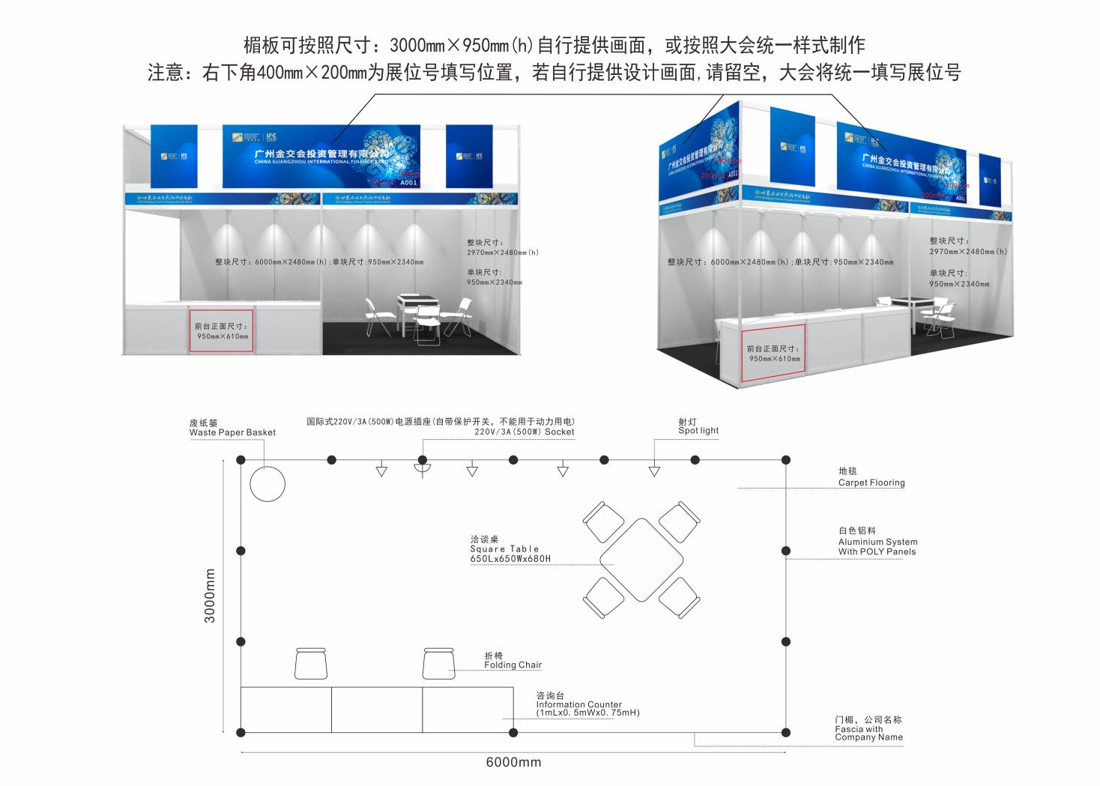
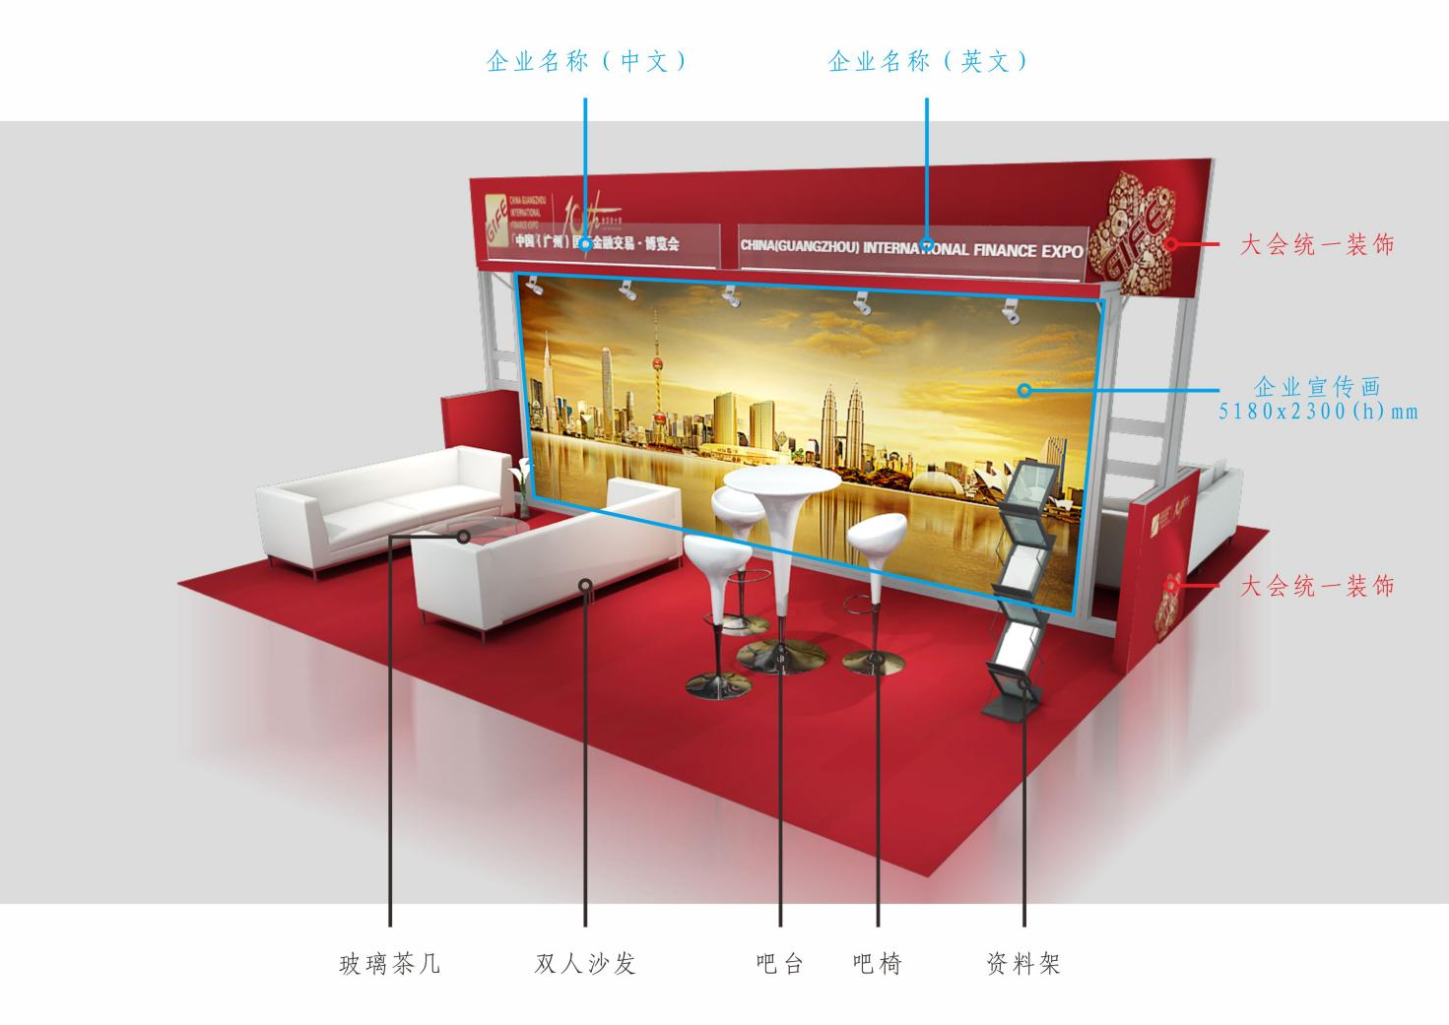

Second, modify the booth configuration and increase the exhibits
(a) The four spotlights included in the standard configuration are fixed to the back panel of the booth. If you need to relocate them, please mark them on the above floor plan or attach a separate drawing to indicate the location of the required facilities, such as spotlights, power outlets, etc. If any facilities are omitted from the booth plan, the decision to install or not to install them will be made by the show's main contractor after careful consideration. Any alteration costs will be borne by the exhibitor.
(b) Application: Exhibitors who need to modify the standard booth configuration (such as fascia board content, removal of hoardings, etc.) and rent additional exhibition equipment, please complete the corresponding schedule and return it to the office of the 11th GIFE Organizing Committee before June 7.
(c) Payment: All orders can be remitted to the main venue contractor Guangzhou Convention and Exhibition Service Center Co., Ltd. before June 15 to pay all the fees, or in cash at the conference service office in the Pearl River Walk, Pazhou Complex A during the exhibition period.
(d) late declaration will be accepted according to the on-site declaration price, please go to the on-site service point for processing, and charge the expedited fee for the relevant service items (see the relevant exhibition service item fees); if the site cancels the early declaration items or temporary changes, the processing fee will be charged at 30% of the early declaration item fee.
(E) Standard booth construction and variation must be made by the main venue contractor designated by the conference. Exhibitors who need additional booth variation will be responsible for their own costs (please contact the conference supervisory unit, contact person: Huang Jun 020-83390606, commissioning deadline: June 7).

Third, the cloth (withdrawal) exhibition notes
(a) For the booths and exhibits built and configured by the General Assembly, the exhibitors and exhibition units are not allowed to disassemble and alter them, let alone take them out of the exhibition hall. Otherwise, the organizing committee of the conference will give verbal warning, suspend the entry documents and force to restore the original state, and the costs and consequences will be borne by the exhibitors themselves.
(2) Exhibitors are not allowed to nail holes, spraying, sawing and using strong adhesives such as foam double-sided adhesive on aluminum brackets and exhibition boards, otherwise, the damaged aluminum brackets and exhibition boards shall be compensated by the exhibitors concerned according to the price. (b) Exhibit boards are RMB 200/block, aluminum columns are RMB 250/branch and flat aluminum is RMB 200/m.
(c) The walls, exhibition boards, channel pillars in the exhibition hall with styrofoam paste or in the sign booth with instant stickers framed bottom, once found, give a verbal warning, order the offender to restore the original state, and pay 200 yuan per square meter (less than 1 square meter by 1 square meter) of cleaning and maintenance fees, while immediately take down the paste.
(4) Electricity of the venue shall be supervised by the electrician of the venue, and the wiring must be done by the electrician of the venue, and private connection of electricity is prohibited. Standard booths (including standard modified booths) are not allowed to install their own lighting fixtures, and are not allowed to declare sockets as the power supply for their own lighting fixtures; private disorderly connection is strictly prohibited, and the power sockets applied for must be used strictly within the maximum allowed capacity of 500W, and must not be plugged with electrical equipment exceeding the allowed capacity, and the use of self-socket boards in series is strictly prohibited. If the fuse is blown due to overload of electricity consumption, the replacement fuse will be charged at 20 RMB/time.
(e) all by the main contractor to provide or rent the exhibition equipment, equipment, the use of units must be returned to the main contractor intact, damage to the price of compensation.
(vi) The use of escalators in the exhibition hall to transport any goods, equipment or furniture is strictly prohibited; in principle, exhibitors are not allowed to hire temporary porters from outside the exhibition hall, and if necessary, porters wearing service marks may be hired from inside the exhibition hall.
(7) The evacuation of the exhibition must be prompt, clean and thorough. Exhibitors shall move their exhibits out of the exhibition hall within the specified time after the closing of the exhibition, and discarded items shall be cleared out of the exhibition hall and transported away by themselves, and exhibitors shall be responsible for the storage of exhibits and materials during the process of evacuation. The exhibitors will be responsible for the storage of exhibits and materials during the withdrawal process. If the booths are not withdrawn or unattended after the specified time and without overtime procedures, the conference will organize special cleaning.
Deadline: June 7, 2022  Post plus exhibition equipment rental application form - standard booth |  | Schedule 3
Please complete and return to.  The Organizing Committee’s Office of GIFE  Contact: Huang Jun（86）20-83390606  Fax: (86) 20-83186940  Email.zc@gzife.com | Booth number: ________________________________  Unit name: ______________________________  Contact: ________________________________  Tel: _________________ Fax: ___________  Email: ______________________________
We reserve the following rental items for use during the exhibition only (June 24-26 for 1 exhibition period)
Number | Projects | Unit price | Unit price | Quantity | Total Price
 |  | (to be declared by June 7) | (filed on or after June 7) |  | (RMB)
FF-01 | 750Inquiry table 990mm(L)×495mm(W)×750mm(H) | 100 | 120
FF-02 | 950 inquiring table 990mm(L)×495mm(W)×950mm(H) | 180 | 216
FF-03 | High and low display cases  990mm(L)×495mm(W)×750mm(H)(low)  990mm(L)×495mm(W)×950mm(H)(height) | 215 | 258
FF-04 | Square table 650mm(L)×650mm(W)×680mm(H) | 100 | 120
FF-05 | Folding Chair | 30 | 36
FF-06 | Bar | 200 | 240
FF-07 | Bar chairs | 200 | 240
FF-08 | Sofa 700mm(L)×700mm(W)×700mm(H) | 300 | 360
FF-09 | Coffee table 1150mm(L)×550mm(W) | 200 | 240
FF-10 | Information rack | 100 | 120
FF-11 | 100 watt spotlight | 100 | 120
FF-12 | 500 watt non-lighting socket | 100 | 130
FF-14 | Round Table | 150 | 180
FF-15 | Jewelry decorative cabinet (with white light) | 450 | 585
TE-21 | DVD | 500 | 600
TE-22 | 50" Plasma TV | 1500 | 1800
TE-23 | 60" Plasma TV | 2000 | 2400
TE-24 | 7500 ANSI lumen projector | 3500 | 4200
TE-25 | 84-inch projection screen (170cm×127cm) | 900 | 1080
TE-26 | 120-inch projection screen (244cm×183cm) | 1200 | 1440
 |  | Date of application: Month and year
 |  | Exhibitor's stamp

Note: June 7 and after the late declaration will be accepted according to the on-site declaration, please go to the on-site service point for processing, and charged an expedited fee of 20% of the applied project cost; if the site cancels the early declaration of projects or temporary changes, then charged a handling fee of 20% of the early declaration project cost.

Reference illustration of post-addition spreader
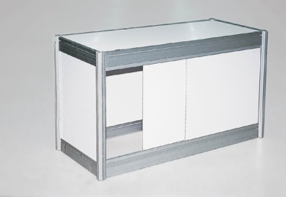 | 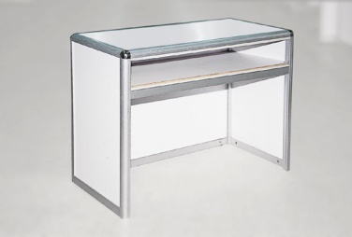 | 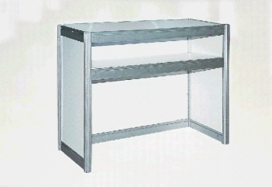 | 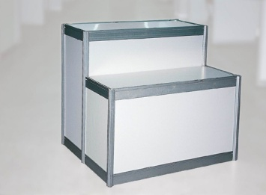
Locker  Specification: 990×495×750 | 750 Inquiry Desk  Specification: 990×495×750 | 950 Inquiry Desk  Specification: 990×495×950 | High and low display cases  Specifications.  990×495×750(low)  990×495×950(H)
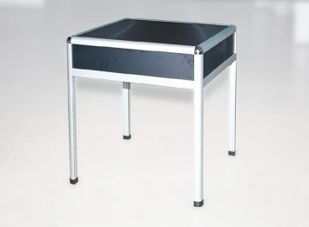 | 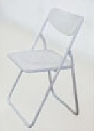 | 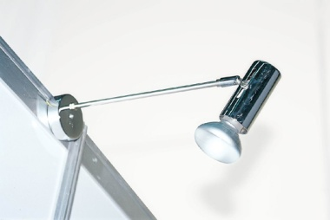 | 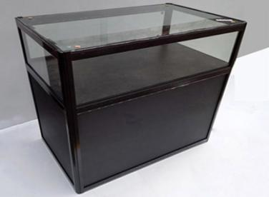
Quadrant  Specification: 650×650×680 | Folding Chair | Spotlights  Specification: 100W | Jewelry cabinet  Specification: 990×495×950
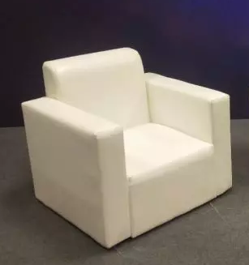 | 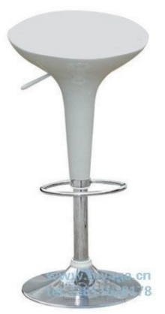 | 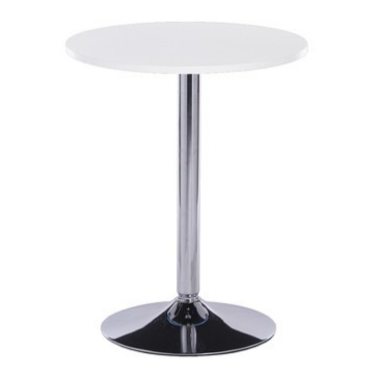 | 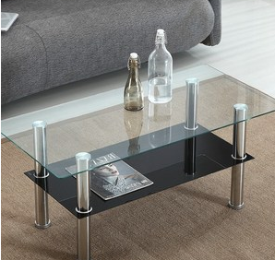
Sofa  Specification: 700×700×700 | Bar chairs | Bar | Coffee table

Chapter IV special booth set up (withdrawal) exhibition instructions

I. Special Decoration Contractor
In order to standardize the management of the exhibition hall, ensure safety and improve the overall level of exhibition, according to the relevant regulations of the exhibition hall, this year's GIFE on General Assembly special decoration exhibition contractor to implement the qualification certification system. The General Assembly recommends the following special decoration and exhibition contractors.
Guangzhou International Exhibition Co.
(Guangzhou International Exhibition Co., Ltd.) was established in 1990, led by the Guangzhou Municipal Committee of China Council for the Promotion of International Trade. (now Guangzhou Industrial Investment Holding Group Co.
With 32 years of experience, Guangzhou International Exhibition Co., Ltd has hosted nearly 100 international exhibitions with a total exhibition area of 3 million square meters, based in Guangzhou, the Bay Area and the world. With the resources of the whole industry chain of exhibition, the company is mainly engaged in three core business sectors of exhibition organization, exhibition service and exhibition engineering design and construction, and is committed to become a comprehensive operator of exhibition industry that drives the high-quality development of urban economy.
Looking ahead, Guangzhou International Exhibition Co., Ltd will certainly continue to improve the marketization, specialization, branding and internationalization of the exhibition industry, promote the integration and development of the exhibition industry and the main industry, and better serve enterprises and the real economy. It will cultivate world-class urban exhibition brand projects, support the construction of Guangzhou International Exhibition Capital and lead the exhibition economy in the Bay Area to take off.
Contact: Wenchao Ye
Tel: 15013117715
E-mail: 346972604@qq.com

Guangzhou KAM-YIK Public Relations Agency Co.
("KAM-YIK PR") was established in 1995, formerly known as Guangzhou Municipal Organ Planning and Communication Center, which is an institution providing planning and execution services for large-scale activities and projects sponsored by government departments. It was renamed as Guangzhou KAM-YIK Public Relations Agency, which is the only organization engaged in public relations and cultural communication under Guangzhou Exchange Group.
Over the years, the company has been responsible for the planning and execution of Guangzhou's key industrial projects in finance, science and technology, biology, brand conferences and exhibitions and public events with the core concept of "Diffuse Guangzhou", based on advanced project management experience and rich resources of government and enterprises, and is a high-quality integrated service provider for government and enterprises in Guangzhou. It is a comprehensive service provider of public relations activities for government and enterprises in Guangzhou.
Contact person: Li Wanling
Tel: 13710298247
E-mail: 3075942812@qq.com

Ⅱ. the GIFE green special booth initiative
In order to fully implement the development concept of "innovation, coordination, green, open and sharing", the GIFE advocates the use of green special booths by major exhibitors. In line with the development trend of special decoration simplification, standardization of components and environmental protection. The design concept reflects the principles of reduction, reuse and recycling; the structure reflects modularity and modularization; the material reflects recycling and recyclability; the display effect reflects the corporate philosophy and the image of enterprises and products.
(i) Basic requirements.
1. Design.
Passed the GIFE special booth design audit.
2. Fire and structural safety.
(1) Pass the fire and structural safety audit of the special booths at the GIFE.
(2) Ensure the overall strength, stiffness, stability and solidity of each connection point of the booth structure.
(3) Strictly in accordance with the national mandatory technical specifications, standards and regulations for the design and construction of decoration projects.
3. Electricity safety.
(1) Pass the GIFE special booth electricity safety audit.
(2) Strictly in accordance with the national technical specifications, standards and regulations for the installation of electrical facilities for construction.
4. Specific requirements are detailed in the Service Manual.
(B) green requirements.
1. Design.
Embodying the 3R principle, viz.
A. Reduce: Use less material to achieve the function of the booth.
B. Reuse (Reuse): requires that the material can be used repeatedly in its initial form.
C. Recycling (Recycle): The materials required to achieve the function of the booth can be economically recovered and reused.
2. Materials.
(1) The use of recycled and recyclable, non-toxic and non-hazardous environmental protection materials or recyclable materials, and in line with the A or B standard.
A. Pure metal profile structure, the use of decorative materials is less than 10% of the total amount of building materials (by volume), and all non-wood materials, and the recycling rate of building materials reaches 100%.
B. Mixed type lumber structure, the use of wood materials is less than 30% of the total building materials (by volume), and the recycling rate of building materials is 100%.
(2) Lightweight, disassemblable, less difficult to load and unload, and easy to transport.
(3) The rate of energy-saving lamps and lanterns is not less than 80%.
3. erection and dismantling.
(1) on-site assembling modular, component-based, orderly, controllable, convenient, safe and fast to build and dismantle.
(2) No damage to personnel, exhibition sites and equipment and facilities; no dust, noise, toxic and harmful gases and waste; no violations.
4. Effect.
(1) Express the corporate philosophy and show the image of enterprises and products.
(2) The booth is permeable and layered, and is not capped with wooden materials.
(3) The display effect is simple, harmonious and beautiful.
(4) Enhance the interactive experience of exhibits.

Ⅲ. the special installation drawings for review process
(A) declaration time: all special installation unit, please June 7, 2022, special installation related design drawings to the organizing committee of the General Assembly, after the net area of 35 yuan per square meter booth special installation management fee, such as one week before the launch of the declaration and delayed installation, the responsibility is their own.
(B) must submit the drawings and information
1. booth design drawings (three-dimensional effects, floor plans, elevations).
2. construction drawings of the booth (including detailed dimensions and material descriptions).
3. Power distribution system diagram (indicating total power, total switch rated current value, total switch voltage (220V/380V), indicating the type of wire used and the laying method).
4. Power distribution plan (indicate the location of the total power distribution box of the booth, the type, power and installation position of the lamps and lanterns; the north-south orientation must be indicated, if no north-south orientation is indicated, it will be defaulted to north and south).
5. Schedule 5 "booth decoration project declaration form" (in the commitment column exhibitors, design units, construction units three parties to add their official seals)
6. Schedule 6 special booth construction safety responsibility guarantee (exhibitors and construction units stamped).
7. Schedule 7 application form for electricity consumption (construction unit stamped).
8. Schedule 8 booth safety electricity responsibility commitment (exhibitors, construction units stamped with the official seal).
9. Schedule 9 volume control commitment (exhibitors, construction units stamped).
The booth design does not allow the fully closed design of the opening surface (the closed wall does not exceed 2/3 of the side length). Contracted construction. All the above design drawings and text descriptions must be printed in color on A4 paper and stamped with official seal (one copy, clear diagrams required); and the information will be scanned and copied to a USB drive for submission of electronic files. All paper materials and USB flash drive are sent by express mail or directly to (Address: 3rd Floor, Building 8, Hotel Canton, 374 Beijing Road, Yuexiu District, Guangzhou, China (Guangzhou) International Finance Expo Organizing Committee Office, received by Wei Yingxu, contact number 13430319199), the General Assembly does not accept fax or e-mail drawing materials.
(iii) Notes.
1. all special booths regardless of the size of the area must be reported to the examination of the drawings, without the declaration or approval of unqualified exhibition, the General Assembly will be forcibly removed and cleaned up, the costs and losses are borne by the exhibition unit.
2. the special installation contractor for all the approval of all the approved drawings, shall not be changed; such as the need to change, subject to review by the General Assembly supervisory unit. For unauthorized changes, the General Assembly has the right not to supply electricity, and give warnings and penalties.
3. The construction of the special installation contractor shall be carried out strictly in accordance with the drawings and shall not exceed the scope of the construction permit, and accept the supervision and inspection of the management personnel of the General Assembly. If irregular construction is found, the management personnel may verbally warn until the cancellation of its construction permit, resulting in all consequences by the contractor is responsible.
4. All the special installation drawings will be sent to Guangzhou fire department for review after preliminary examination by the supervisory unit, and the construction will be allowed only after the audit is passed. For the drawings that do not pass the audit, the design unit will be notified to modify the plan until the audit is passed.

Ⅳ. the special installation of electricity to declare
(a) Application acceptance procedures.
1.Application: Please fill out the "Application Form for Electricity for Special Booth" according to the power consumption of the booth and submit it to the office of the Organizing Committee of GIFE before June 7.
2.Payment of fees: All orders must be submitted to the main site contractor by remittance before June 15, 2022
Account name: Guangzhou Exhibition Service Center Co.
Bank of Account: Bank of China Guangzhou Canton Fair Sub-branch
Bank account number: 7003 7355 1461
(b) Where special installation construction, the use of performance machinery power electricity, increased booth lighting and the use of fax machines, computers, printers, televisions, refrigerators, light boxes and other electrical equipment, regardless of power size, before entering the site must be truthfully reported to the General Assembly Organizing Committee office for review of the electrical load.
(c) For the sake of electricity safety, special booths must rent the electric box of the exhibition hall and pay the corresponding electricity fee and deposit for the electric box. You must apply for a temporary electric box for construction use; each booth can only apply for one; the temporary electric box for construction use can only be used for air pump, tool charging, etc., and is not allowed to be used for test light or equipment testing. The exhibitors must provide their own electric control box with isolation switch, air circuit breaker and leakage protector qualified by relevant departments according to the electricity consumption of the booth. After the construction is completed, the power supply shall be energized only after inspection by the auditing department.
(d) has installed the safety management of the electrical box from the time of delivery to the withdrawal of the exhibition refund deposit on the electrical box by the construction unit is responsible for the period, such as the damage occurred to the electrical box, all responsibility by the construction unit, depending on the damage deducted from the corresponding deposit.

V. Booth construction management regulations
(a) The ground load on the second floor of Area A of Pazhou Complex is 1.35 tons/square meter.
(b) To ensure the normal operation of the fire alarm system, automatic sprinkler system and power distribution system, all booth decoration cannot be capped in any form and shall not block or obstruct the fire-fighting equipment of the exhibition hall in any form. No items shall be placed within 1 meter of the front of the fire hydrant, and each booth shall be equipped with at least 2 portable fire extinguishers (5KG dry powder fire extinguishers are recommended).
(c) special design and exhibition, should pay attention to the space parameters in the exhibition hall, the minimum distance of 2.5m from the ground for overhanging installation, all overhanging installation of lamps and lanterns, must be more than 2.2m from the ground, the installation of sockets must be 30cm from the ground, power control box should be installed in the height of 1.8m ~ 2m above the ground, can not meet the conditions, must be placed in the rest of the personnel can not touch the place and set up a person It is strictly forbidden to place sockets and power control boxes on the ground.
(d) All decoration and decorative materials should be non-combustible or non-combustible materials, and all decoration construction should be done in the form of assembling in the exhibition hall after pre-production of semi-finished products of booths and exhibition stands in the local area and applying 0.5kg of oil-based fireproof paint per square meter.
(e) Specially decorated exhibition shall not be used in the ground, walls, nailing, drilling, hitting the pull-out screws and other ways to fix the booth construction.
(f) within the column position requires packaging trim, should be assembled on the form of screws installed to facilitate disassembly, and pay attention to the protection of fire paint on the column, good mat protection; such as the column has a public electric box part, should be left with 60 × 100cm electric box mouth, to avoid affecting the electrician to connect the pavilion overhaul. If there is a fire exit emergency sign in the column, the position of the sign should be left empty.
(g) electricity shall comply with the "Electricity Safety Regulations"; design and installation of electrical equipment, a single-phase circuit shall not exceed 16A, beyond 16A should be equally distributed by three-phase access, and equipped with earth leakage switches, air circuit breakers and electrical boxes lead to the power junction. Prohibit the use of high-power lamps and lanterns above 500W.
(h) The overall effect of special booth design.
1. booth design should adopt simple structure, simple system, both reusable and environmentally friendly materials, the part using paint shall use water-based environmental protection paint (recommended to use sea poly water-based paint). The wall on the side of each booth channel should be made of semi-transparent materials or windows, and should not be in the form of a fully enclosed wall. The air circulation and air conditioning environment in the booth should be fully considered.
2. If the booth belongs to the enclosed way, the straight-line distance is more than 15 meters, the doorway must be opened in the north and south main channel to ensure fire safety.
3. All visible backboards (including the backboards of the super-high part between adjacent booths) must be decorated, and it is recommended to use white material for the decoration treatment; no advertising and promotional information shall be released for the super-high part of adjacent booths facing adjacent booths.
4. The vertical projection of the booth for special installation shall not exceed the scope of the reserved open space. The design and production of special installation must be carried out within the vertical projection area of its booth, and shall not extend outward in any form or affect the space of adjacent booths.
5. If the same exhibitor uses more than one booth and there is a public channel in the middle of all its booths, it shall not cross the channel or build a second floor aisle when designing.
(i) In order to ensure the normal performance of the fire-fighting facilities and air-conditioning equipment of the exhibition hall, each design unit and construction unit must design and build in strict accordance with the height specified in the exhibition hall (the overall height limit of the exhibition hall is 4.5 meters). The design and construction units are required to pay high attention to the fact that the construction will be prohibited if it directly affects the facilities and equipment of the exhibition hall.
(j) To ensure the safety of the exhibition, the construction unit is recommended to purchase insurance for its booth including but not limited to public liability insurance, employer's liability insurance and all risks of the project. The total amount of insurance for each booth should not be less than 3 million. The construction unit can entrust the main venue contractor Guangzhou Convention and Exhibition Service Center Co., Ltd. to purchase the exhibition liability insurance (including public liability insurance and employer's liability insurance) according to its needs, please contact Wei Yingxu 13430319199 for details.
(k) the preparation and withdrawal of the exhibition during the epidemic prevention initiatives.
1. the preparation and withdrawal of the exhibition during the strict implementation of the "code check - temperature measurement - verification - into the pavilion" process.
2. during the operation of the pavilion, you need to wear a mask and helmet throughout to ensure that safety protection is in place to reduce the risk of infection.
3. It is strictly forbidden to work with bare bladder and slippers to avoid direct contact between personnel to prevent infection.
4. During the operation, avoid direct contact with eyes, nose or mouth after touching the plates, construction tools, handling tools and exhibits with your hands, and it is recommended to wear gloves if you have conditions.
5. Exhibits from medium and high-risk areas must be disinfected and disinfected before entering the pavilion.
6. Tools with incoming operations need to be disinfected and disinfection treatment in advance to maintain cleanliness and hygiene.
7. Do a good job in a timely manner to clean up the garbage plates, installation and scrap in the construction area to keep the operating environment neat and clean.

Ⅵ. the exhibition notes
(a) All booth arrangements shall be solid and safe, and the exhibitor shall be fully responsible for any damage to personal property caused by collapses and falls due to insecurity.
(b) The ceiling and fixed facilities of the exhibition hall are not allowed to hang any objects; no damage or demolition of any hardware facilities of the exhibition hall; no nails, screws or holes shall be driven into any part of the exhibition hall; it is strictly prohibited to use double-sided and single-sided adhesive materials to paste any objects on the columns and walls of the exhibition hall; if you need to paste on the stone floor or walls of the exhibition hall, only non-residual single-sided or double-sided adhesive is allowed; no The use of other adhesive materials is not allowed.
(c) the exhibition samples used during the exhibition unpacking, shredded paper, foam, wood chips and other flammable packaging must be cleaned out of the pavilion in a timely manner before the opening of the General Assembly, it is strictly prohibited to store them in the booth, the top of the cabinet or behind the booth board wall, such as violations, in accordance with relevant regulations.
(d) shall not be in the exhibition hall pedestrian passage, stairway intersection, elevator door, fire facilities, power supply facilities, communication equipment and air-conditioning unit return air outlet and other sections of the arbitrary placement, hanging, nailing all kinds of exhibition samples, promotional materials or other signs.
(e) No damage shall be done to the facilities of the exhibition hall, the arrangement of the open space and the road shall not affect the traffic, no damage shall be caused to the glass curtain wall of the exhibition hall, and no access and construction of exhibits shall be allowed within the lobby of the exhibition hall.
(f) The staff of each organizing unit or exhibitor may carry their own exhibits and equipment, and the General Assembly has designated carriers at on-site service points to provide paid handling services for exhibitors, and the General Assembly prohibits other units from providing paid handling.
(g) No escalators may be used to carry exhibition samples, and those who damage escalators or other facilities must bear all costs of repair.
(h) all exhibitors, special installation contractor without the consent of the General Assembly, when entering the venue is not allowed to bring the same or similar exhibits with the original exhibits into the exhibition hall to set up the exhibition, the withdrawal of the exhibition shall not carry the exhibits out of the exhibition hall;
(i) The distance between the booth and the power supply box shall be not less than 80CM, and the distance between the booth and the wall shall be not less than 60CM, and shall not block the fire fighting facilities or occupy the fire fighting channel.
(j) The maintenance and electrical safety management of the special booths shall be the responsibility of the contractor, who shall designate a person to manage them and be available for contact at any time.

VII. Notes on the withdrawal of the exhibition
(a) June 26, 2022 16:00 before the withdrawal of the exhibition is strictly prohibited, if found early withdrawal of the special installation contractor, will be included in the bad record list of the General Assembly, cancel the special installation qualification certification qualifications, three years shall not participate in the General Assembly special installation construction, and deduct the booth clearance deposit of 5,000 yuan.
(b) In the process of evacuation, exhibitors will be responsible for the storage of exhibits, exhibits and materials, and will be responsible for any loss or theft; for those who rented exhibits in the exhibition hall, please go to the on-site service point for return procedures and receive the corresponding deposit.
(c) The evacuation of the exhibition must be prompt, clean and thorough. All exhibitors shall remove all materials from the exhibition hall within the above specified time, and the abandoned exhibition materials shall be cleared out of the exhibition hall and transported away by themselves. If any exhibition materials are left on site, a deposit of RMB 10,000 yuan will be deducted from the booth and the qualification of special installation will be cancelled, and the exhibitor will not be allowed to participate in the special installation construction for three years.
(d) For booths that have not gone through overtime procedures and have not been withdrawn or left unattended after the specified withdrawal time, the General Assembly will be specially organized to clean up, and the General Assembly will not be responsible for the lost items and exhibition boards and exhibits, and the deposit for the clearance of the special booths involved will not be refunded, and the qualification certification of the special booths will be cancelled, and they will not be allowed to participate in the special construction of the General Assembly within three years.
(e) the withdrawal of special exhibition material vehicles with cloth (withdrawal) exhibition car card on June 26 after 16:00 into the exhibition site, the vehicle shall enter the exhibition hall in accordance with the command of the staff in turn, the vehicle into the loading must immediately drive out of the pavilion, not the turn of the vehicle according to the command of the staff to park the vehicle in the designated position in line.

Ⅷ. Deposit refund process
(a) Deposit for electric box: The electrician of the exhibition hall will be responsible for checking the electric box of the exhibitor's booth and dismantling it uniformly, if there is no damage, the deposit will be refunded within 15 working days after the exhibition; if damage occurs, the deposit for the electric box will be deducted accordingly.
(b) Clearance deposit: The on-site service point staff will be responsible for checking the withdrawal of the exhibitor's booth, and if the cleaning is completed, the staff will sign on the "Clearance Confirmation Form " and return the deposit within 15 working days after the exhibition; if the cleaning is incomplete (including the garbage left outside the pavilion) or the site facilities are damaged, the deposit will be deducted accordingly. The deposit will be deducted accordingly.

Ⅸ. vehicle driving safety practices
(a) during the preparation and withdrawal of the exhibition hall outside the truck driving route requirements
A area during the preparation and withdrawal of the exhibition truck driving route: Eastbound Xingang Road - Ke Yun Road overpass turnaround - westbound Xingang Road East - northbound Exhibition West --Reading River Road Gate 8 entrance
(b) vehicle driving requirements
1. During the preparation and withdrawal of the exhibition, cars, buses and passenger vans are not allowed to drive into the exhibition hall, park, wait or load and unload goods according to the specified areas, and vehicles entering the second and third floor exhibition hall are limited to 10 meters (including 10 meters), 5 tons (including 5 tons) and 3.8 meters (including 3.8 meters) in height. Over-length, over-weight and over-height vehicles must be unloaded and passed in the parking lot designated by the exhibition hall. The vehicles entering the exhibition hall shall obey the scheduling of the exhibition hall, and the driver shall not leave the vehicle and drive away from the exhibition site after loading and unloading the goods.
2. During the conduct period, all vehicles are parked according to the prescribed area, parking hours are: 08:30-17:00, vehicles are not allowed to stay overnight. Leaking oil and vehicles containing flammable, explosive, toxic, radioactive or polluting substances are prohibited from entering the parking lot. Smoking, the use of open fire, washing and maintenance of vehicles is strictly prohibited in the parking lot, the vehicle should be parked in time to close the doors and windows, their own custody of valuables, car, card separation, parking card should be carried, no parking card or can not prove that the person is the owner of the vehicle shall not be released from the field.
3. Vehicles entering the exhibition hall area should follow the route specified during the exhibition, and the driving speed should not exceed 10 km/h. Vehicles over 2.2 meters high are not allowed to enter the underground parking lot of the exhibition hall. Bicycles are not allowed to enter the parking lot.
4. The garbage removal truck shall comply with the relevant safety regulations of the exhibition, and the vehicle parking and garbage stacking shall not occupy and block the fire fighting facilities.
(c) During the exhibition, if any vehicle needs to be driven to the exhibition hall for display purposes and parked, it is necessary to fill out and submit the "Application for Sample Vehicle Entering the Hall" (consult the supervisory unit) and follow the requirements of the relevant regulations on it.

Charges for special installation-related services
I. Regular service charges (RMB: yuan, billing period: exhibition period)
Projects | Unit | Unit price (yuan) | Remarks
Special installation construction management fee | Yuan/sqm | 28 | Based on the net area of the booth (report the map on or before June 7)
Special installation construction management fee | Yuan/sqm | 35 | Calculated by net booth area (report map after June 7)
Second, the extended service charges (RMB: yuan, billing cycle: 3 hours)
Projects | Unit | Unit price (yuan) | Remarks
Extended service fee  (Overtime) | Yuan/M²/  3hours | 20 | Charge according to the net area, the starting area of each exhibition hall 100M² , 3 hours as the billing period, less than 3 hours according to 3 hours, more than the day 15:30 application for an additional 20%
Third, the deposit calculation standards (RMB: yuan, billing cycle: extension)
Projects | Unit | Unit price (yuan) | Remarks
Special booth clearance deposit | Yuan/booth | 20000 | Area of 100 square meters or less, excluding 100 square
 |  | 30,000 | Area of 100 square meters or more, including 100 square meters
Deposit for electrical box | RMB/pc | 500
IV. Electricity and deposit for electric box (Schedule 7)
Number | Electrical box specifications | Electricity prices  (to be declared by June 7) | Electricity prices  (filed on or after June 7) | Electrical box  Rent | Electrical box  Deposit
EB-01 | 10A/220V(2.2KW) | 500 | 650 | 350 | 500
EB-02 | 16A/220V(3.5KW) | 750 | 975 | 350 | 500
EB-03 | 10A/380V(5KW) | 900 | 1170 | 350 | 500
EB-04 | 16A/380V(8KW) | 1500 | 1950 | 350 | 500
EB-05 | 20A/380V(10KW) | 1800 | 2340 | 350 | 500
EB-06 | 25A/380V(13KW) | 2100 | 2730 | 350 | 500
EB-07 | 32A/380V(16KW) | 2400 | 3120 | 350 | 500
EB-08 | 40A/380V(20KW) | 2700 | 3510 | 350 | 500
EB-09 | 50A/380V(25KW) | 3000 | 3900 | 350 | 500
EB-10 | 63A/380V(30KW) | 3600 | 4680 | 450 | 500
EB-11 | 100A/380V(50KW) | 5800 | 7540 | 450 | 500
Temporary electricity for construction | 10A/220V(2.2KW) | 300 | 390 |  | 500
Temporary electricity for construction | 10A/380V(5KW) | 600 | 780 |  | 500
Note: The above fees must be paid in full before the launch to receive the documents and enter the exhibition, otherwise, no entry, no power supply in the exhibition hall.
The construction deposit must be paid by the certified construction unit, and the invoice will only be issued on behalf of the exhibitor or the certified construction unit.
Deadline: June 7, 2022  Optional special display construction unit responsibility commitment |  | Schedule 4
Please complete and return to.  The Organizing Committee’s Office of GIFE  Contact: Wei Yingxu  （86）20-83390606  Fax: (86) 20- 83186940  Email.zc@gzife.com | Booth number: ________________________________  Exhibitors: ______________________________  Contact: ________________________________  Tel: _________________ Fax: ___________  Email: ______________________________

Optional special display construction unit responsibility commitment

For our own reasons, we give up to consider the certified builder recommended by the organizing committee of GIFE and choose ( ) as our contractor for booth construction, and guarantee the safety of the booth, if there is a safety accident, our company and the contractor will be jointly responsible.
Special Booth Contractor (seal) Exhibitor (seal)
On-site contact cell phone number: On-site contact cell phone number:
Date: Date:

The Organizing Committee recommends exhibitors to use qualified and certified contractors for booth design and construction. If you choose a contractor other than a qualified contractor, please ask the contractor to submit qualification documents (see requirements below) and pay a construction safety deposit of 200,000 RMB (the same amount as the deposit paid by the qualified contractor). Exhibitors using the Organizing Committee's certified contractors are not required to fill in this form.
Qualification documents.
1. A copy of the business license of the legal person and a copy of the tax registration certificate.
2. Certificate of "Display Engineering Enterprise Qualification".
3. Unit profile.
4. The unit has the technical strength of the supporting documents. Including copies of professional qualification certificates of designers and engineers, and copies of induction certificates of other tradesmen related to exhibition projects.
5. Proof of ownership or lease of the site where the workshop was made.
6. To prove that the unit has experience in special decoration display or has engaged in large and medium-sized exhibitions (more than 50,000 square meters) of special decoration display experience (issued by the exhibition organizers to prove or the original contract).
7. The unit design and construction capacity and other supporting information.
The above materials are also checked for the original.

Deadline: June 7, 2022  Booth decoration project declaration form - special booth |  | Schedule 5
Please complete and return to.  The Organizing Committee’s Office of GIFE  Contact: Wei Yingxu（86）20-83390606  Fax: (86) 20-83186940  Email.zc@gzife.com | Booth number: ________________________________  Exhibitors: ______________________________  Contact: ________________________________  Tel: _________________ Fax: ___________  Email: ______________________________
Contractors of special installation booths must be qualified and approved by the organizing committee of GIFE before entering the pavilion to build.
Unit Type | Unit Name | Contact person | Contact number | Mailbox
Exhibitors
Design Unit
Constructor
Exhibitors  Commitment | I undertake to supervise the relevant units in strict accordance with the national mandatory technical standards for decoration works and the requirements of the relevant management regulations of the China Import and Export Fair Pazhou Complex for design and construction, any violation of responsibility.  Signature of person in charge: (unit seal)
Design Unit  Commitment | We promise that the decoration and design of the booth will be in accordance with the national mandatory technical standards for decoration works and the requirements of the "Guangzhou Area Electrical Installation Regulations", and in accordance with the relevant management regulations of the China Import and Export Fair Pazhou Complex, and we will be responsible for any violation.  Signature of the person in charge: (unit seal)
Constructor  Commitment | I promise that in the process of booth decoration, in strict accordance with the audited design drawings, the China Import and Export Fair Pazhou Complex "exhibition construction management regulations" requirements for the construction, any violation of responsibility at your own risk.  Signature of the person in charge: (unit seal)
- This application form exhibitors, design, construction unit responsible for the three signatures (seal), otherwise it is considered invalid.
- The structural safety of the special installation booth needs to be reviewed and stamped by a first-class structural engineer.
- This application form should be submitted to the Organizing Committee Office of the Congress at the same time as the proposal for special decoration by June 7, 2022.
- All information submitted for review must be used A4-size paper and scanned to a USB flash drive while reporting for review, faxes and e-mails are not accepted.
- The General Assembly supervisory unit received the application form and confirm that it is correct, five working days after the announcement, the reporting unit can call directly to inquire.

Deadline: June 7, 2022  Special Booth Construction Safety Responsibility Guarantee - Special Booth |  | Schedule 6
Please complete and return to.  The Organizing Committee’s Office of GIFE  Contact: Wei Yingxu（86）20-83390606  Fax: (86) 20-83186940  Email.zc@gzife.com | Booth number: ________________________________  Exhibitors: ______________________________  Contact: ________________________________  Tel: _________________ Fax: ___________  Email: ______________________________
Special booth construction safety responsibility guarantee

Exhibition Date: June 24-26, 2022
Exhibition Name: The 11th China (Guangzhou) International Finance Expo
Our company is responsible for the construction of the exhibition booth number: , exhibitor: , booth area of a total of square meters of special decoration construction contractor, has received the "11th China (Guangzhou) International Finance Expo Service Manual ". We promise to design and construct the booth in strict accordance with the national mandatory technical specifications and the requirements of "Fire Safety Management Regulations", "Electricity Safety Management Regulations" and "Construction Safety Management Regulations" of China Import and Export Fair Pazhou Complex. If in the process of construction and removal of the exhibition, violate the above relevant management regulations, our unit is willing to accept the provisions of the relevant management regulations of the venue. For the construction quality or brutal construction of special booths during the set-up, launch and withdrawal of the exhibition, which leads to the occurrence of safety accidents. Our unit is fully responsible for the accident and is willing to bear all the economic and legal responsibilities caused by it.

Special Decoration Contractor (seal) Exhibitor (seal)
On-site contact cell phone number: On-site contact cell phone number:
Date: Date:

Our unit guarantees that the above personnel are employees of our unit. If for any reason our personnel cause any consequences in the exhibition areas of the exhibition hall, our unit is willing to assume the relevant legal responsibility and compensate for all the losses caused by this.

Enterprise signature.
 | Deadline: June 7, 2022  Electricity application form - special booth |  |  |  |  |  | Schedule 7
 | Please complete and return to.  The Organizing Committee’s Office of GIFE  Contact: Wei Yingxu（86）20-83390606  Fax: (86) 20-83186940  Email.zc@gzife.com |  |  | Booth number: ________________________________  Exhibitors: ______________________________  Contact: ________________________________  Tel: _________________ Fax: ___________  Email: ______________________________
Number |  | Electrical box specifications | Electricity prices  (to be declared by June 7) |  | Electricity prices  (filed on or after June 7) | Electric box rental |  | Deposit for electrical box | Quantity
EB-01 |  | 10A/220V(2.2KW) | 500 |  | 650 | 350 |  | 500
EB-02 |  | 16A/220V(3.5KW) | 750 |  | 975 | 350 |  | 500
EB-03 |  | 10A/380V(5KW) | 900 |  | 1170 | 350 |  | 500
EB-04 |  | 16A/380V(8KW) | 1500 |  | 1950 | 350 |  | 500
EB-05 |  | 20A/380V(10KW) | 1800 |  | 2340 | 350 |  | 500
EB-06 |  | 25A/380V(13KW) | 2100 |  | 2730 | 350 |  | 500
EB-07 |  | 32A/380V(16KW) | 2400 |  | 3120 | 350 |  | 500
EB-08 |  | 40A/380V(20KW) | 2700 |  | 3510 | 350 |  | 500
EB-09 |  | 50A/380V(25KW) | 3000 |  | 3900 | 350 |  | 500
EB-10 |  | 63A/380V(30KW) | 3600 |  | 4680 | 450 |  | 500
EB-11 |  | 100A/380V(50KW) | 5800 |  | 7540 | 450 |  | 500
Temporary electricity for construction |  | 10A/220V(2.2KW) | 300 |  | 390 |  |  | 500
Temporary electricity for construction |  | 10A/380V(5KW) | 600 |  | 780 |  |  | 500
- Rental of 24-hour electricity must be applied for by June 7 and charged at three times the corresponding electricity cost rate for electricity consumption.

________________  Date |  |  | ______________  Signed and stamped

Remark.
1. For the sake of electricity safety, exhibitors must use the electric box of the exhibition hall and provide their own electricity control box equipped with isolation switch, air circuit breaker and leakage protector qualified by relevant departments according to the electricity consumption of their booths. The electric box provided by the exhibition hall will only be used as a power extension and cannot replace the exhibitor's own total control box.
2. The electric box of the exhibition hall will be installed to the booth by the electrician of the exhibition hall, and the exhibitors will be responsible for the electricity connection under the switch of the electric box (inside the booth) and will be supervised by the electrician of the exhibition hall. Another deposit of 500 RMB/each will be charged for the electric box.
3. For 63A and below power consumption, this fee includes: electricity, electric box rental, cable fee, auxiliary materials and labor cost.
4. For 63A or above power consumption, this fee includes: electricity, electric box rental, 30m cable fee, auxiliary materials and labor fee, if the length of the cable used exceeds 30m, additional cable fee will be charged (63A-100A:25RMB/m, 150A:40RMB/m, 200A:50RMB/m, 250A:70RMB/m, 300A and above:90RMB/m).
5. A 30% surcharge will be added for late filing on or after June 7.
6. Construction electricity must be applied for construction temporary electricity box; each booth can only apply for one; construction temporary electricity box can only be used for air pump, tool charging, etc., not allowed for test light or equipment testing. It should be equipped with a secondary electric box, which should be equipped with isolation switch, air switch and leakage protection device.
Payment Terms
All purchase orders are to be paid in full by June 15, 2022 in the following manner.
1) Remit to the following account number
Account name: Guangzhou Exhibition Service Center Co.
Bank of Account: Bank of China Guangzhou Canton Fair Sub-branch
Bank account number: 7003 7355 1461
(2) Cash Receiving Unit: Guangzhou Exhibition Service Center Co.
Address: Room 712, Oriental Finance Building, No.140 Dongfeng West Road, Guangzhou
June 7 and after the late declaration will be accepted according to the on-site declaration, please go to the on-site service point for processing, and charged an expedited fee of 30% of the applied project cost; if the site cancels the early declaration project or temporary changes, then 20% of the early declaration project cost will be charged a handling fee.

Deadline: June 7, 2022  Booth Safety Electricity Liability Commitment - Special Booth |  | Schedule 8
Please complete and return to.  The Organizing Committee’s Office of GIFE  Contact: Wei Yingxu（86）20-83390606  Fax: (86) 20-83186940  Email.zc@gzife.com | Booth number: ________________________________  Exhibitors: ______________________________  Contact: ________________________________  Tel: _________________ Fax: ___________  Email: ______________________________
Booth Safety Electricity Responsibility Commitment
In order to cooperate with China Foreign Trade Center (Group) (hereinafter referred to as "the Pavilion") to do a good job in the safe electricity management of the exhibition booth of the GIFE Complex, to clarify responsibilities, standardize management, ensure safety, and create a safe and reliable exhibition environment with electricity, according to the "GIFE Complex Safety Electricity Management Regulations" (hereinafter referred to as "the Regulations"), this unit As a unit of the 11th China (Guangzhou) International Finance Expo (booth number: ), and the construction contractor of the booth, we hereby undertake to the exhibition hall.
A. Strictly abide by the "Regulations", and bear direct responsibility for all consequences caused by electrical installation or unauthorized use of electricity during the preparation and withdrawal of the exhibition and its development; bear the corresponding economic and legal responsibilities.
B. Designate a person to be responsible for the safety of the booth during the exhibition preparation and withdrawal and the development of electricity, do a good job in the preparation and withdrawal of the exhibition and the maintenance of the site during the exhibition, timely elimination of electricity safety hazards to ensure the safety of the booth.
C. Obey the supervision and management of the relevant departments of the exhibition hall, and effectively implement the measures of electricity safety and rectification.
Two copies of this undertaking shall be executed by the exhibition hall, one by the exhibitor and one by the construction contractor, and shall be effective from the date of stamping and signing.
This commitment form is a necessary attachment to the Booth Electricity Declaration Form.

Exhibitors.
(Official seal)
Legal representative or person responsible for security (signature).
Person responsible for site safety or site electrician.
Contact number.
Date: Year Month Day

Booth contractor.
(Official seal)
Legal representative or person responsible for security (signature).
Person responsible for site safety or site electrician.
Contact number.
Date: Year Month Day

Deadline: June 7, 2022  Volume Control Commitment --Special Booth |  | Schedule 9
Please complete and return to.  The Organizing Committee’s Office of GIFE  Contact: Wei Yingxu（86）20-83390606  Fax: (86) 20-83186940  Email.zc@gzife.com | Booth number: ________________________________  Exhibitors: ______________________________  Contact: ________________________________  Tel: _________________ Fax: ___________  Email: ______________________________
Volume control commitment
As an exhibitor of the 11th China (Guangzhou) International Finance Expo, our company has the obligation to ensure that the on-site environment of the conference is suitable for financial institutions to promote their products and negotiate on site.
This move is beneficial to the activities of on-site exhibitors and allows visitors to have a good visiting environment. If affected by other exhibitors' noise, our company will regulate their behavior by means of written complaints and will not engage in volume competition.
If our company violates the volume provisions of this undertaking, our company is willing to accept the punishment of the Organizing Committee of GIFE and bear the consequences.

Hereby promise

Special Booth Contractor (seal) Exhibitor (seal)
Live volume controller: Live volume controller:
On-site contact cell phone number: On-site contact cell phone number.
Date: Date：

All special installation contractors are obliged to ensure smooth transaction at the conference site. Please assist their responsible booths to control the booth volume below 70 decibels during the exhibition period, and if the booth volume is too loud and causes nuisance to other booths and is complained in writing for more than three times, RMB 5,000 will be deducted from the deposit each time starting from the fourth written complaint. Please fill out and return the volume control commitment form with your seal for the financial institutions you serve.

Deadline: June 7, 2022  Communication and Multimedia Services Application Form |  | Schedule 10
Please complete and return to.  The Organizing Committee’s Office of GIFE  Contact: Wei Yingxu（86）20-83390606  Fax: (86) 20-83186940  Email.zc@gzife.com | Booth number: ________________________________  Exhibitors: ______________________________  Contact: ________________________________  Tel: _________________ Fax: ___________  Email: ______________________________
We reserve the following rental items for use during the exhibition only.
Services | Content | Number | Specific description | Early Price | Remarks | Quantity | Total Price  (RMB)
Internet Access | Wired Broadband | TE-01 | 5M broadband (applicable to 5 terminals, only support switch networking, need networking service to be declared separately). | 1600RMB/strip/exhibition period
 |  | TE-02 | 15M broadband (applicable to 10 terminals, only support switch networking, need networking service to be declared separately). | RMB 3200/strip/exhibition period
 |  | TE-03 | 30M broadband (applicable to 20 terminals, supporting only switch networking, requiring networking services to be declared separately). | RMB 5500/strip/exhibition period
 | Fiber optic dedicated line | TE-04 | 10M private line (contains only one common public IP, can be wired to group by itself, 10 terminals recommended). | 7000RMB/strip/exhibition period | Applications closed 5 days before opening
 |  | TE-05 | 20M private line (contains only one common public IP, can be wired to set up your own network, 20 terminals recommended). | RMB12,500/strip/exhibition period
 |  | TE-06 | 30M private line (contains only one common public IP, can be wired to set up your own network, 30 terminals recommended). | 18000RMB/strip/exhibition period
 |  | TE-07 | 40M private line (contains only one common public IP, can be wired to group by itself, 40 terminals recommended). | RMB22,000/strip/exhibition period
 |  | TE-08 | 60M private line (contains only one common public IP, can be wired to set up your own network, 60 terminals recommended). | RMB 28000/strip/exhibition period
 |  | TE-09 | 100M private line (contains only one common public IP, can be wired to set up your own network, 100 terminals recommended). | 55000RMB/strip/exhibition period
 |  | TE-10 | Private network public IP address | RMB 1300/each/exhibition period
 |  | TE-11 | Special specification bandwidth | Price is negotiable
Networking Services | Wired networking | TE-12 | Provide network switch and network cable at RMB 400 per port, starting from RMB 1200 for 3 ports and RMB 400 for each additional port | 1200RMB/exhibition period
Link Rental | Network Link Rental | TE-13 | Rental of showroom network access at $1600 per point | 1600RMB/exhibition period/each
 | Fiber optic link rental | TE-14 | Rental Showroom Fibre Channel Service | Price is negotiable | Applications closed 5 days before opening
 | DPLC/IPLC Domestic Dedicated Line | TE-15 | 10M, 100M fiber optic point-to-point links with exclusive 10MB, 100MB point-to-point dedicated; | Price is negotiable
Wireless Network | Wireless Charter Service Package | TE-16 | 10,000㎡ and below, including export bandwidth 200M, customized signal name, customized authentication page (including an exhibition information page), can accommodate 5,000 people online at the same time | 40,000 RMB/exhibition period
 | Text message authentication | TE-17 | Starting from 50,000 messages, each additional 30,000 messages, the charge is 3,000 RMB, SMS function only supports the network of Chinese mainland operators | 13,000 RMB/exhibition period
 | WiFi addition | TE-18 | Including an AP device, network cabling, power supply, configuration and other engineering and construction services, technical maintenance during the exhibition period, certification and certification page, including 1000 SMS, can cover 100 ㎡~150 ㎡ | 11,000 yuan/exhibition period/each
 | VIP-WiFi Account | TE-19 | For wireless terminal Internet access, limited to one terminal online at the same time | 500RMB/exhibition period | Full time application available

Remark.
1. According to the National Network Security Management Law and related management regulations, the public network services of Canton Fair Complex need to implement the real-name authentication system according to the regulatory requirements.
2. Advance price is implemented before entering the site, and on-site price is implemented after entering the site (30% additional charge on the basis of advance price).
3. Applications for each service item, except for special remarks, will be closed at 12:00 noon 2 days before the opening.
4. access to the exhibition hall party network computer should install the latest virus database antivirus software, such as the normal operation of the exhibition hall party network behavior, the exhibition hall party will be depending on the severity of the claim.
5.The broadband line belongs to the hardware facilities of the venue, the right to explain the use of the facilities belongs to the venue.
Payment Terms
Please report by June 7, 2022 and pay by June 15 for the order to be effective; bank remittance will be based on the statement; all orders will be confirmed by full payment; unpaid orders will not be accepted and no refund will be made for cancellation.
(1) The above fees must be remitted to the following account number by June 15, 2022.
Account name: Guangzhou Exhibition Service Center Co.
Bank of Account: Bank of China Guangzhou Canton Fair Sub-branch
Bank account number: 7003 7355 1461
(2) Cash Receiving Unit: Guangzhou Exhibition Service Center Co.
Address: Room 712, Oriental Finance Building, No.140 Dongfeng West Road, Guangzhou

Example of special declaration
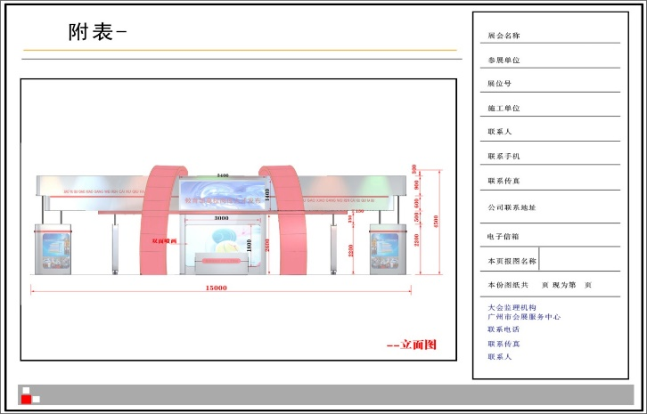
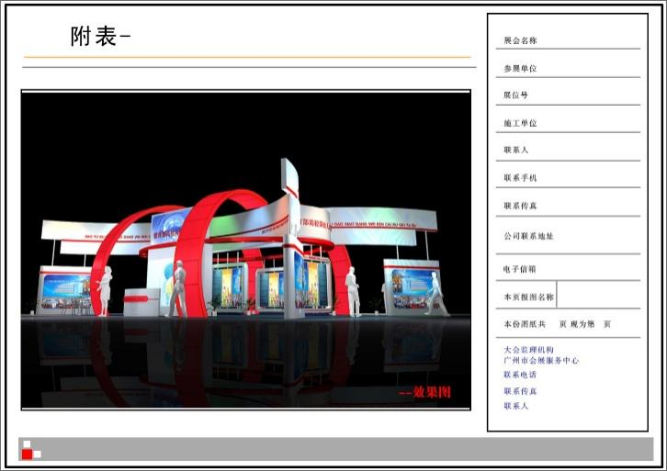
The following six diagrams as a reference for each special unit to report the diagram, each special unit should be strictly referred to, each diagram is printed in color on A4 paper and scanned to a U disk to submit.
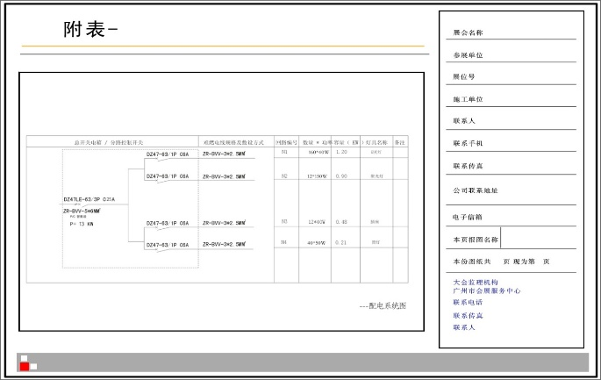
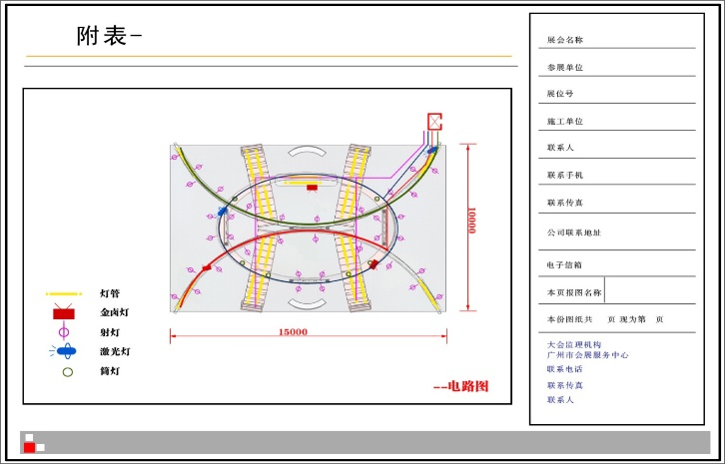
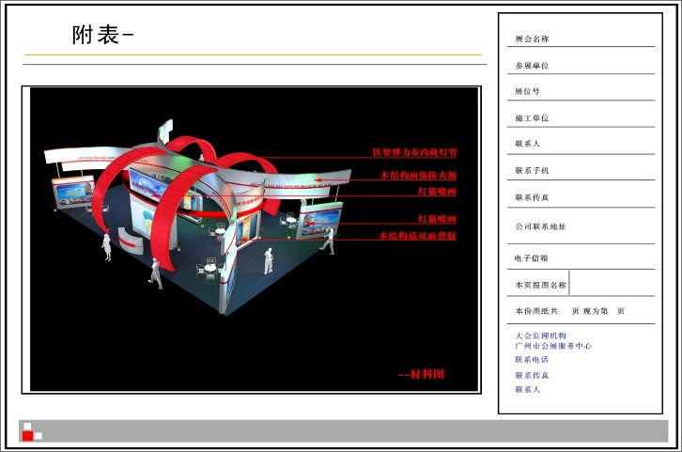
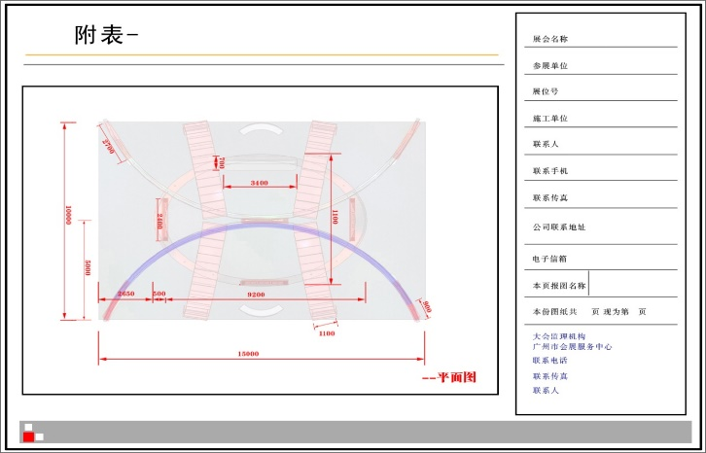

Chapter V Exhibition Hall Management Regulations

I. Fire safety management regulations
All exhibitors, contractors and staff, etc. must comply with the Fire Services Law of the People's Republic of China and the relevant fire safety regulations of the China Import and Export Fair Pazhou Complex.
(a) Smoking is strictly prohibited in the exhibition hall.
(b) to keep the channel open, the main channel width shall not be less than 6 meters. Evacuation doors should be open and unobstructed, and shall not be locked. It is strictly prohibited in the channel and building (elevator) in front of the display and display samples, violators are ordered to remove.
(c) strictly prohibit the indiscriminate connection, pulling wires and unauthorized installation of electrical equipment (including lighting, advertising lighting). Do need to install, be sure to declare to the General Assembly contractor in advance, approved by the General Assembly review, the electrician must be licensed to work. Installation materials must be qualified products, such as the use of substandard products in violation of the provisions of the accidents and disputes caused by the exhibitors are responsible. The installation should use flame retardant wires and comply with the safety regulations of electricity, and the power supply can only be used after acceptance.
(d) their own decoration of the exhibition site, the construction of booths, booths (stands), billboards (racks), etc., must be declared in advance to the General Assembly contractor, approved before construction. Decoration materials should use fire-retardant plywood or non-combustible materials, otherwise they are considered illegal and ordered to remove.
(e) No items are allowed to be hung on the ceiling and fixed facilities of the exhibition hall. The distance between the booth and the electric box shall be not less than 80CM. No fire fighting facilities such as fire hydrant shall be blocked, misappropriated, encircled or damaged in the construction, decoration and exhibition.
(f) in the exhibition hall is strictly prohibited to use electric stove, electric kettle, electric iron, iodine tungsten lamp and other electric heating apparatus and high-power lamps, the exhibition hall is strictly prohibited to use neon lights.
(g) is strictly prohibited to bring toxic or dangerous goods into the exhibition, including: flammable liquids, compressed gases and dangerous, highly toxic chemical products, such as exhibition samples are only allowed to use substitutes. If the construction, performance really need, must be reported to the security department for approval beforehand, the use of a person in charge to ensure safety.
(h) in the construction, performance, open flame work (welding, gas welding, etc.) is strictly prohibited.
(i) exhibitors' boxes, debris, confetti and excess exhibition samples must be cleaned up in time and transported out of the exhibition area, and it is strictly prohibited to store them in the booth, the top of the counter and the back of the booth or on the channel between booths. Violators will be punished and ordered to clean up.
(j) The amount of gasoline stored in the fuel tank of any sample car must not exceed 4 liters, otherwise the responsibility for fire safety caused by this shall be borne by the exhibitor. All sample cars must be submitted to the "Application for Entry of Sample Cars" before June 7, and follow the requirements of the relevant regulations on it, otherwise the vehicles cannot enter the hall; contact Wei Yingxu 13430319199 for details.
(k) Anyone who finds a safety hazard, please notify the General Assembly immediately. In case of emergency, please remain calm, obey the unified command of the conference staff and evacuate in an orderly manner.
(l) Responsibility
1. Exhibitors shall bear and be responsible for any expenses or claims for compensation arising from their related persons and purchases during set-up, exhibition and take-down, so as to protect the interests of the Organizer and the person in charge of the venue.
2. The contractor shall not be responsible for any conditions beyond the control of the contractor that result in the booth not being erected, altered, dismantled or the exhibition center not being able to provide a particular service or any changes in the regulations and codes.
3. The organizer reserves the right to cancel the exhibition completely, cancel part of the exhibition or postpone the exhibition. Arrangements for booth fees will be made on a case-by-case basis at that time.

Ⅱ. electricity safety management regulations
(a) Electricity supply: The General Assembly provides basic exhibition hall lighting.
(b) The standard power supply is: three-phase five-wire system, 380 volts / 220 volts (V) 50 Hz (Hz), the maximum load of 100 amps, if there is a greater demand for electricity, should apply in advance.
(c) The water and electricity supply to the booths will be turned off 30 minutes after the end of the exhibition each day. If you need 24-hour electricity supply, or delayed power or water cut-off, please contact the conference contractor as soon as possible and pay an additional fee.
(d) the exhibition of basic technical requirements for electrical installation
(GB50303-2002), "Design Code for Distribution of General Electricity Equipment (GB50055-94)" and other codes, as well as the relevant fire safety regulations of the exhibition hall and the specific requirements of this provision, according to the construction of the scheme drawings approved by the exhibition hall; the total control box must use metal material electrical box.
2. The low-voltage power supply system of the exhibition hall adopts the three-phase five-wire system. The voltage level is 380V/220V, 50HZ, and the power distribution of the exhibition area (booth) should be three-phase five-wire system or single-phase three-wire system. If the voltage and frequency required by the exhibitors' equipment are different from those of the exhibition hall, the exhibitors or contractors should bring their own power conversion devices to solve the problem.
3. The number of electrical equipment (including lamps and sockets) in each protection circuit of the lighting distribution shall not exceed 25 sets, with a total capacity of less than 3KW or 16A current.
4. three-phase non-mechanical power load greater than or equal to 20A current, must be set up air break switches graded protection. Single-phase load greater than 16A current, three-phase power distribution should be used, the average distribution of electrical load, to achieve a three-phase power distribution balance.
5. booths must provide their own booth electricity total control electrical box, equipped with safe and reliable air circuit breakers and leakage protectors (30mA, action time less than 0.1S) according to the specifications, installed in a safe, obvious and convenient location for operation and inspection.
6. The total switch protection setting value of the total control box for booth electricity shall be lower than or equal to 80% of the switch protection setting value of the fixed power box in the exhibition hall to ensure the safe operation of the power supply system of the exhibition hall. If the switch protection value of the booth cannot be matched, the exhibitor or the construction contractor shall adjust the electricity consumption by themselves until it meets this requirement.
7. The selected electrical materials and equipment and facilities should conform to the national product quality standards and certifications and meet the fire safety requirements of Guangzhou City. Electrical materials must be equipped with sufficient safe load capacity. Wires should use ZR-BVV (flame-retardant double plastic copper-core wire), ZR-RVVB sheathed wire or ZR-VV cable, prohibit the use of twisted wire (flower wire) and aluminum-core wire. Lamp rectifiers and triggers shall be used to fire department inspection qualified products.
8. general lighting class, mechanical power class, frequency conversion equipment, silicon controlled equipment, stage dimming equipment class, sound reinforcement equipment and 24-hour power equipment should be set up according to the classification of independent circuit, is strictly prohibited to share the same circuit. Important electrical equipment and important occasions, location of electricity should be installed a main and a double-loop power supply.
(e) electrical construction safety management
1. On-site electrical construction personnel should carry with them the valid electrician's operation certificate issued by the national technical supervision department and obey the verification of the exhibition hall. The pavilion party prohibits personnel without valid electrician's operating certificate to engage in electrical installation.
2. Process the electricity procedures and provide temporary construction electricity by the exhibition hall. If you do not go through the construction procedures and pay the relevant fees, the exhibition hall will not supply electricity.
3. Conduct electrical construction in strict accordance with the plan and drawings approved by the exhibition hall, and control the electrical load within the approved total load. If the site really needs to increase electrical appliances and other electrical equipment and exceeds the declared load, you should declare for the relevant procedures in time and pay the relevant fees according to the regulations.
4. Contractors must provide their own construction power distribution box (configuration leakage protection switch); all electrical installation should be installed by electricians with valid documents; construction of power tools should be tested to meet safety requirements; construction of temporary power lines should be used with sheathed copper-core flexible wire, the middle must not have a connector, must be configured to protect the switch; power cord is strictly prohibited to plug directly into the power outlet or hang in the switch blade end of the electricity, must be use plugs and fastening port dowels to connect.
5. The total switch and power access line (cable) of the total control box for booth electricity shall meet the standard requirements, with reference to the total power consumption, choose the switch and wire with matching voltage and current level; according to the configuration of the power supply system of the exhibition hall and the safety technical requirements, the power connection of all kinds of electricity shall be subject to the power connection mode, route and location specified by the exhibition hall, and shall be taken on the terminal block of the power supply and distribution facilities or special power plugging. It is forbidden to access the electric box and socket of the exhibition hall at will; it is forbidden to connect the total control box of the booth with the total switch protection setting value greater than 80% of the fixed power distribution facilities of the exhibition hall.
6. All metal frame, equipment and facilities metal shell must be reliably grounded (using not less than 2.5mm² multi-stranded soft-core copper wire). Electrical line laying must be fixed, not arbitrarily laid in the exhibition frame, ground and channel. Electrical lines through the walkway must have a bridge plate protection, through the carpet and dark laid in the decoration of the wire, the middle can not have an interface, must be protected with a casing (metal pipe or non-combustible plastic pipe), metal pipe well grounded across the body. Prohibit the use of ceiling and pipe hanging wires, lighting fixtures and other objects.
7. No high-power lamps and lanterns of 500W or above shall be used in the booth. The use of heat-generating lamps (such as quartz lamps, tungsten iodide lamps) must be equipped with protective covers. Downlights and quartz lamps must be protected by heat insulation pads. Convection heat dissipation holes must be left in advertising light boxes and lampposts. Electrical appliances and lighting equipment in outdoor open-air booths must be of waterproof type with reliable safety measures against rain, moisture, wind, etc.
8. A distance of more than 30cm should be maintained between all installed lamps and exhibition samples and other items. All equipment and facilities installed with heat sources shall be kept at a distance of more than 3 meters from the fixed power distribution facilities of the exhibition hall and shall not discharge heat towards the fixed power distribution facilities.
9. The booth layout shall not block the lighting, power supply box (cabinet) and telephone wiring box of the exhibition hall. A channel of not less than 60cm and sufficient operating space must be left for safety inspection and troubleshooting.
10. After the electrical installation of the booth is completed, the exhibitor and the contractor should do a good job of self-checking the safety of the power distribution system before the official power supply. The electrician of the exhibition hall and the electrician of the contractor shall jointly check and confirm that the electricity supply is qualified before closing the gate.
11. During the exhibition period, exhibitors or contractors must arrange booth duty electricians to deal with the problems found in time to ensure the safety of electricity. During the set-up and exhibition period (especially before closing), the lamps and lanterns installed in the booths should be checked daily to see if they fall off, and if they are found to fall off, they should be dealt with immediately to avoid damaging the exhibition samples and causing safety accidents.
12. The construction contractor shall educate its construction personnel on civilized construction and safety, and the construction personnel shall work within the declared approved period and working area, and shall not work in non-working area and time without approval. If violation of this provision causes all safety accidents and responsibilities, the construction contractor shall be fully responsible and bear all economic losses caused to the pavilion and third parties as a result.
13. No exhibitor, contractor or individual has the right to operate any electrical facilities fixed and configured in the exhibition hall without the approval or authorization of the exhibition hall party, and shall not be connected and used privately, and violators shall be held responsible and compensated for the losses caused.
Emergency treatment for power failure
1. The exhibitors or contractors are responsible for the troubleshooting of the booths. During the exhibition period, when the electricity of the booth breaks down, the electrician on duty at the booth should deal with it in time and troubleshoot it, and it is strictly forbidden to close the electric gate with faults.
2. If the exhibition hall's fixed power distribution facilities switch protection tripping leads to booth blackout, the electrician on duty at the booth should first check whether the electrical equipment and lines are faulty and eliminate them, and at the same time immediately notify the electrician of the exhibition hall to deal with the situation. If accidents and economic losses are caused by unauthorized switching, the relevant personnel and units will be held responsible.
3. If there is a power failure in the booth during the exhibition period, the exhibition hall has the right to adjust the power lines and load for the exhibition to ensure the safety of the exhibition, and the exhibitors and contractors must cooperate.
4. The exhibition hall will notify the electrician on duty at the booth to deal with the safety hazards of electricity, and may take compulsory measures such as cutting off the power supply to ensure safety. If serious safety hazards or violations are found, the exhibition hall has the right to stop the power supply without notice in order to ensure safety.
(f) If 24-hour power supply is required for booths, the 24-hour power supply declaration and approval form shall be filled out. 24-hour power supply shall be equipped with independent power circuits and suitable and reliable protection switches to ensure that the equipment is free from hidden faults. The exhibitors shall arrange electricians to be on duty 24 hours a day to ensure the safety of electricity in the exhibition hall.
(g) mechanical power supply and silicon-controlled stage dimming equipment and other special power distribution lines that do not allow (or are not suitable) for the installation of 30mA leakage protectors, exhibitors or contractors should apply for approval through the main contractor and sign the "Application for Removal of Ground Well Leakage Protection Switching Device" and "Voluntary Waiver of Leakage Protection Device Commitment"; during the implementation process, exhibitors or contractors should take strict and adequate protection measures to ensure the safety of the power supply system and personal safety.
(h) Computers, precision instruments and other equipment should be installed with uninterruptible power supply to protect, due to power supply interruption caused by computers, precision instruments and other equipment data loss and damage, the exhibition hall is not responsible for compensation.
(i) shall not use high-powered electric heating equipment (such as electric kettles, electric stoves, electric irons), such as the need for electricity, must apply to the customer service center for approval before use.
(j) Exhibitors or contractors using their own compressors must specify when declaring electricity consumption. All compressors brought into the exhibition hall should comply with the relevant safety standards and regulations and must be placed at the location designated by the exhibition hall so as not to affect the exhibition environment and safety.
(k) The exhibitor or contractor assumes all responsibility in the event of.
1. Losses caused by the failure of the equipment and electrical wiring of the booth resulting in the loss of power due to the protective action of the power switch of the pavilion.
2. Not in accordance with the provisions, specifications for the design and installation of power distribution lines, losses caused by power supply failures in the process of use; not in accordance with the declaration of the approved drawings, the construction of power distribution lines and loads that do not match the declaration of audit, losses caused by power supply failures in the process of use.
- No exhibitor or contractor electrician on duty, unable to deal with the loss caused by power failure in a timely manner.
4. Found serious safety hazards or violations, to ensure safety, the Pavilion party to take mandatory measures such as cutting off the power caused by the loss.
5. Losses caused by power failure of important, expensive and specially required electrical equipment and facilities and exhibits without special protection measures (such as self-contained emergency power supply devices, etc.).
6. Other losses caused by the fault of the exhibitor or contractor.
(l) The exhibition hall and the exhibitors and contractors shall be exempted from liability to each other for losses caused by natural disasters such as earthquakes and floods, power outages in the municipal grid, government emergencies and other irresistible factors.
(m) The exhibition will be closed every day and the exhibition will be closed and withdrawn, the exhibition hall will take the security measures of power outage, during this period, if you want to temporarily retain electricity, you should submit a written application for electricity to the exhibition site service point in advance.
(n) special booth power supply supervision flow chart
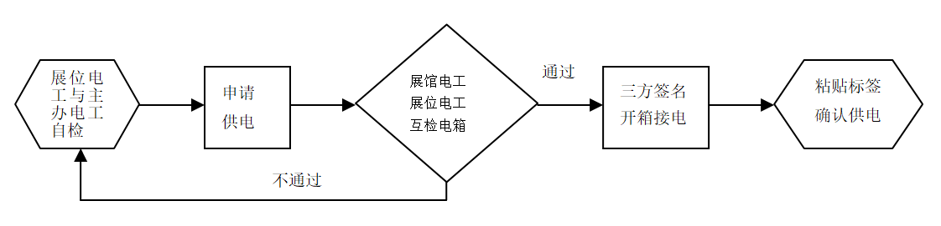

Ⅲ.Booth construction and construction guidelines
(a) The construction personnel of the special installation booths should be licensed (exhibition preparation certificate, exhibition removal certificate, electrician certificate, etc.), strictly follow the relevant requirements of the exhibition to construct according to the drawings, accept the supervision and management of the exhibition hall, and wear safety helmets to the construction site. Construction units should not build or demolish booths indiscriminately, and the vertical projection of all special exhibition booths should not exceed the scope of the reserved open space.
(b) Construction units should be safe and civilized, work at height with good protective measures, wear and fasten helmets and safety belts to ensure safety and avoid casualties caused by falls. Do not use cutting machines, chainsaws and welding machines on site; do not paint or spray paint on site; do not build or hang all kinds of decorative shapes on the passages outside the booths without approval; all decoration frames must be solid and reliable, and the placement of exhibition samples must be stable to avoid collapse and falling causing casualties and property losses; do not dismantle special booths in a brutal manner. The construction unit will be responsible for any loss of personnel and property caused by the above-mentioned actions.
(c) The construction of special booths is limited to 4.5 meters in height. With glass or wood panel material roofing are installed hanging 6 kg dry powder fire extinguishers, every 20 ㎡ configuration one, 20 ~ 30 ㎡ configuration two, and so on. Cloth material roofing, cloth and cloth need to leave 20 cm interval between, and according to every 5 ㎡ / kg spray fire retardant (nylon cloth, mesh cloth according to 8 ㎡ / kg). If you do not leave an interval as required to use cloth material capping, according to the wood panel material treatment.
(d) All decoration materials should be non-combustible or non-combustible. Please do not use grass, bamboo, rattan, paper, bark, foam, reed, combustible plastic board (universal board), combustible carpet, fabric and wood board as decoration materials in the exhibition hall. The finished products or semi-finished components have been developed, for special reasons not using flame-retardant materials, should be declared to the Security Department of the Customer Service Center before entering the site, and after approval, the party can be treated by applying 0.5 kg of fireproof paint per square meter. Accepted by the exhibition hall party before installation.
(e) Booth construction involving glass exhibits shall follow the following regulations.
①The glass area of the booth decoration exceeds 1.5㎡ or the installation height of the glass exceeds 1.5m, tempered glass is required.
② glass installed in more than 1.5m position, regardless of the size of the area will always use tempered glass. Each piece of glass installation must be pressed, plus code, and shall not be used for load-bearing support.
(f) special booth enclosed set area of more than 60 ㎡ (including 60 ㎡), need to set up 2 outlets; each special booth within at least one floor pit electrical box inspection activities to retain the mouth.
(g) The special installation contractor and exhibitor shall be responsible for the safety and quality of the construction of the booth, and the special installation contractor and exhibitor shall be liable for any loss of life and property due to collapse of the booth, falling objects, fire, etc. The exhibition hall, the organizing committee and the main contractor shall not be liable for any damages and joint and several liability.
(h) the use of open-air venues for exhibitions also need to pay attention to the following matters.
1. exhibitors open-air electricity leakage protection switch (electrical box) shall be 10-15CM from the ground, please do not open-air exposed placed, pay attention to waterproof.
2. In case of natural disasters such as windstorm and rainstorm, the organizer should inform the exhibitors to take protective measures as early as possible and cooperate with the relevant arrangements of the exhibition hall.
(i) outdoor exhibition shed because there is no spray protection, fire rating is reduced, if you need to lay carpet, you should use fire-retardant carpet or fire treatment (spray fire retardant).
(j) For large special booths with an area of more than 100m² or more, if there is a demand for telephone installation, the booth contractor will lay the internal telephone lines of the booth according to the standard of telephone line placement and usage location, set RJ11 junction box at the terminal, and lead the telephone lines centrally to the junction box of the booth against the backboard of the main channel, with the junction box 30cm above the ground, and reserve more than 1m length of lines in the box for centralized access construction and maintenance. Maintenance.

Ⅳ. construction safety management specifications
1. Work at height requirements
(1) prohibit the use of wooden structure herringbone ladders or rudimentary splicing type herringbone ladders.
(2) must be on the ladder before the safety inspection of the human ladder, to ensure that the tools are safe and reliable.
(3) the pavilion herringbone ladder is limited to 2m in height, only one person is allowed to work on the ladder, and cannot stand at the top of the herringbone ladder to work.
(4) during the operation of the ladder, the ladder must be arranged under the supervision of a person.
(5) Construction personnel shall not use man-ladders for movement.
(6) more than 2m above the height of construction requires scaffolding, and not more than 2 layers.
(7) scaffolding to accommodate a maximum of 2 people working at the same time, construction must be fastened with safety belts (safety buckle needs to be buckled in the rack), if the bottom of the scaffolding with pulleys, need to arrange 1-2 people to help fix
(8) construction operations exceeding 2 levels of scaffolding height, construction requires the use of engineering lift trucks.
(9) Construction workers are prohibited from throwing and transmitting tools when working at height.
2. No open flame or smoking is allowed in the exhibition hall (including offices, halls, conference rooms, booths, Pearl River walkway, warehouses, corridors, bridges, front rooms of buildings (elevators), bathrooms, coffee rooms, etc.).
3. Hand-held electrician tools operating requirements
(1) Confirm that the site power supply voltage, frequency and handheld power tools nameplate identification, handheld power tools to start, first no-load operation, check and confirm that the tool linkage is flexible and unhindered before operation.
(2) operators stand in a smooth place, maintain body balance, during the use of power tools, must be installed with splash-proof leakage protector, and the leakage protector installed outside the narrow places, work with supervision.
(3) in the general place of operation, hand-held power tools and equipped with rated action current less than 15mA, rated action time less than 0.1s leakage protector, and the operator must wear insulated gloves for operation.
(4) handheld power tool power cord in the ground when dragging, should take protective measures to prevent being crushed, tripping personnel.
(5) When operating, the force should be smooth, avoiding excessive force, and the workpiece should be fixed firmly to prevent displacement during the operation.
(6) It is strictly forbidden to pull the power cord of hand-held power tools to move the tool, or pull the plug when yanking the power cord to prevent damage to the power cord and rupture of the insulation layer.
(7) closely observe the sound and tool temperature changes during operation, and stop immediately for inspection if abnormalities are found; when the tool temperature is too high, suspend operation and continue operation after the tool cools naturally; it is strictly forbidden to touch the drill bit, grinding wheel and other parts by hand, and if they are found to be blunt, deformed or broken, they should be immediately repaired or replaced, and continue operation after normal.
(8) When there is an unexpected stop, the switch on the hand-held power tool should be turned off immediately to prevent injury caused by the sudden operation of the tool.
(9) When the handheld power tools are not used temporarily during the operation, the tool switch should be turned off and the power supply disconnected to prevent accidental touching of the tool start button and sudden operation of the tool, resulting in injury to personnel.
(10) When cleaning iron chips, wood chips and other debris, special tools or gloves should be used to prevent cuts; when contacting hot workpieces, special tools or gloves should be used to prevent burns.
(11) It is strictly forbidden to dismantle the mechanical safety guards of tools without authorization, and it is strictly forbidden to work without safety guards.
4. helmet wearing requirements
(1) All personnel entering the pavilion during the preparation and withdrawal must wear helmets.
(2) Safety helmets must comply with national quality standards "safety helmets (GB2811-2007)", "technical specifications for the safety of construction work at height (JGJ80-2016)", etc., with factory certification labels or safety certification, and within the shelf life.
(3) helmets must be adjusted to tighten the size, tighten the jaw belt to prevent falling off, to avoid the occurrence of human falls or secondary strikes when the helmet falls off.
5. Construction personnel requirements
(1) All construction personnel entering the pavilion operations must wear construction permits.
(2) All special operation staff must wear relevant special operation documents, such as electrician's license, special equipment operator's license, etc..
(3) Construction personnel shall not wear slippers, sandals and other shoes into the pavilion operations, dress shall not show bare shoulders.
(4) Construction personnel who are drunk, sick or unwell are strictly prohibited from entering the construction site.
(5) during construction shall comply with the production safety rules and regulations of the pavilion, carry out civilized construction, and shall not engage in violence, brutal operations and other acts.
(6) construction personnel need to wear, wear the appropriate protective props or equipment during the operation.
(7) Construction should be carried out within the declared approved period and work area, and construction should not be carried out in non-working area and time without approval, and must obey the on-site management of the exhibition hall party and consciously accept the supervision of the exhibition hall party.
6. Construction units should be safe and civilized construction.
(1) Work at height to do a good job of protective measures, wear and fasten the helmet and seat belt to ensure safety, to avoid injuries caused by falling. Such as the use of man-ladders, scaffolding, the use of aerial work vehicles and other related tools and facilities.
(2) Prohibit open fire operations at the exhibition hall site, such as cutting machines, chainsaws and welding; prohibit air pollution caused by painting and spraying at the site.
(3) without approval, not in the booth outside the channel to build or across the hanging all kinds of decorative modeling, affecting the movement of vehicles and obstruct the fire channel.
(4) All decoration frames must be solid and reliable, and the placement of exhibition samples must be stable to avoid collapsing and falling causing casualties and property losses.
(5) Do not dismantle special booths in a brutal way, such as forcibly pushing to and destroying exhibition panels.
7. Special vehicle operations safety management norms
(1) The use of special vehicles such as forklifts, tractor-trailers, truck cranes and other special vehicles into the pavilion operations, in accordance with the provisions of the exhibition hall need to submit "special vehicles into the pavilion operations safety commitment" (consulting supervision unit), after review before entering the pavilion.
(2) special vehicle operators need to hold the relevant special equipment operators card to work, and prohibit unlicensed personnel to operate special vehicles and equipment.
(3) special vehicle operations before the construction unit should carefully check the potential hazards of the construction area, and only after confirming the safety of the construction work can begin.
(4) Before using special vehicles, the operator should thoroughly check the equipment to ensure normal operation before starting construction work.
(5) During the operation of special vehicles, the exhibition organizers and contractors should cooperate with the exhibition hall to do a good job of supervision and management throughout the work.

V. Food safety management norms
According to "Food Safety Law of the People's Republic of China," Article 61 provides that: the centralized trading market operators, counter renters and exhibition organizers, shall review the permits of food operators admitted in accordance with the law, clarify their food safety management responsibilities, regularly inspect their operating environment and conditions, and if they are found to have violated the provisions of this law, they shall promptly stop and immediately report to the local county-level people's government Food and drug supervision and management departments.
1. Food business (including on-site production and sales) requirements
(1) "Food Safety Law of the People's Republic of China" Article 35: The state food production and operation of the licensing system. Engaged in food production, food sales, catering services, shall obtain a permit in accordance with law. Local people's governments at or above the county level food and drug supervision and management departments shall, in accordance with the "People's Republic of China Administrative Licensing Law", review the applicant submit the relevant information required by the first paragraph of Article 33 of this Law, the first to fourth, if necessary, the applicant's production premises for on-site verification; meet the prescribed conditions, granted permission; do not meet the prescribed conditions, not permit and written Explain the reasons.
(2) According to "food business licensing management methods" Article 9, 10, 11, 12 requirements.
① Apply for a food business license, should first obtain a business license and other legal subject qualifications.
② application for food business license, should be made in accordance with the food business entities and business project classification.
③ Apply for a food business license, should meet the relevant safety and health conditions.
④ application for food business license, should be submitted to the applicant's local food and drug supervision and management departments at or above the county level the following materials: application for food business license; business license or other copies of the main qualification documents; and food business with the main equipment and facilities to adapt to the layout, operational procedures and other documents; food safety self-examination, health management of employees, purchase inspection records, food safety accident disposal, etc. Rules and regulations to ensure food safety.
2. On-site free food (pre-packaged food) requirements
(1) According to "Food Safety Law of the People's Republic of China" Article 53: The purchase of food should check the supplier's license and food factory inspection certificate or other proof of conformity.
(2) According to the "Food Safety Supervision and Management Code for Catering Services at Major Events".
① Article XII food service providers to provide food service for major events, food service food safety responsibilities in accordance with the law to ensure food safety.
② Article XIII catering service providers should actively cooperate with food service food safety supervision departments and their staff assigned to the supervision and management, the supervision departments and their staff to make serious rectification of the comments made. Before a major event, food service providers should sign a responsibility commitment with the food service food safety supervision department.
③ Article XIV food service providers should establish a major event food service food safety work management agencies, the development of major events food service food safety implementation plan and food safety accident emergency response program, and will be timely food service food safety supervision departments and organizers.
④ Article 15 catering service providers should develop recipes for major events, and food service food safety supervision department review; implementation of raw material procurement control requirements, to determine qualified suppliers, strengthen procurement inspection, the implementation of proof of receipt, purchase inspection and ledger registration system to ensure that the purchased food, food additives and food-related products meet food safety standards.
⑤ Article 20 of the following circumstances, food service providers should stop using the relevant food, food additives and food-related products: laws and regulations prohibit the production and operation of food, food additives and food-related products; inspection and testing of substandard drinking water and food; more than the shelf life of the food, food additives; outsourcing of bulk direct-entry cooked food products; regulatory departments in the recipe review identified as unsuitable Suitable for the provision of food.
3. According to the above relevant laws and regulations, the exhibition organizer and the service providers entrusted to the exhibition, as well as the exhibition visitors must obtain permission to engage in food business (including sales and catering services) in the exhibition hall in accordance with the law. The organizer is obliged to inform all visitors and service providers of the exhibition and supervise them to strictly comply with the relevant regulations in the exhibition. The organizer is obliged to check the relevant licenses, and to stop the acts of engaging in food service without obtaining the license to engage in food business according to the law, and to reflect to the relevant departments.
4. To ensure food safety at the exhibition, the exhibition organizers must remind exhibition visitors not to bring or order take-away food from outside the exhibition hall for consumption, and remind non-operating catering service providers introduced in the exhibition hall to provide food with food business license.
5. According to the principle of local management, the relevant licensing and supervision departments are as follows.
Guangzhou Haizhu District Market Supervision Administration Law Enforcement Brigade is responsible for food safety supervision at the exhibition site.
Tel: 020-84010619, 89635329; Fax: 020-89635329
Address: 5th Floor, Yingxin Talent Apartment, No. 2442, Xingang East Road, Haizhu District

Ⅵ. Network security management specifications
1. Broadband users must comply with relevant state laws, regulations and the relevant regulations of the China Foreign Trade Centre, strictly implement the security and confidentiality system, not to use the network to engage in illegal and illegal activities such as endangering national security, leaking state secrets, damaging the interests of the China Foreign Trade Centre, not to produce, access, copy and disseminate information that disturbs public order, offends morals, obscene and pornographic, not to use the network to attack and You may not use the network to attack or damage public network facilities or other users. Otherwise, the customer service center has the right to terminate its network services, and if the situation is serious or causes damage, it will be dealt with according to the relevant national regulations, until the legal responsibility.
2. You may not use the network resources of the exhibition hall for business activities without permission. Once found, the customer service center has the right to terminate its network use.
3. No broadband user may set up and turn on non-terminal devices such as wireless routers to connect to the exhibition hall network without the written permission of the customer service center; if there is a special need, the user must seek written permission from the customer service center, go through the relevant procedures and use them under the guidance of the exhibition hall staff.
4. Any broadband user shall not privately set up a wireless network with signal strength greater than or equal to 90dbm within 2 meters without written permission, otherwise, once found, the customer service center has the right to suspend its relevant equipment until the end of the same period of the exhibition. If you really need to build your own wireless network, you need to submit an application to the customer service center, and after approval, build your own under the guidance of the customer service center staff.
5. Customer Service Center has the right to use technical means to monitor all network security within the Canton Fair Complex. For broadband users who use their own wireless routers, switches and other equipment to connect to the exhibition hall network without the written permission of the customer service center, the customer service center has the right to take measures such as suspending the relevant equipment until the end of the exhibition, confiscating the deposit for the use of broadband network, blacklisting, and disqualifying the broadband users of the two exhibitions (multiple measures can be taken at the same time).
6. The pavilion only provides network channel services, each broadband user must do their own information security protection, all the consequences caused by personal reasons shall be borne by the account applicant. The security protection includes and is not limited to the security protection of Internet access devices, patching the relevant system and installing anti-virus software to prevent the leakage of personal information such as authentication user name and password, etc.
7. Broadband users are not allowed to damage the network equipment and facilities in the exhibition hall, and bear the responsibility of compensation if there is damage.
8. For the need to ensure the safety and smoothness of broadband services, the Customer Service Center has the right to control the network and adjust or prohibit access to some network access ports (such as securities, BT, Xunlei, games, etc.) in some areas and some time periods without prior notice.
9. The Customer Service Center and its related organizations shall not be responsible for any inconvenience or loss caused by the use of broadband services by broadband customers.
10. Telecom operators or enterprises with other special wireless network needs can contact the customer service center to discuss relevant cooperation agreements.
11. After the user successfully declares the broadband service and pays the corresponding fee, the construction will be completed within the time specified by the exhibition hall, and the network will be officially opened on the opening day.
12. The pavilion broadband access is a pairing system, that is, the user is provided with the corresponding number of casualty accounts and passwords according to the type of broadband applied for, and devices exceeding the number will not be able to access the Internet.
13. Users are strictly prohibited from installing Trojan horse software, virus tools and other malicious computer programs to illegally attack or invade the pavilion network and interfere with the normal use of other users.
14. Users are strictly prohibited from using Xunlei, Internet Express, BT, eDonkey and other multi-threaded or P2P download software to download movies, videos and other applications that consume large amounts of network bandwidth.
15. Users must protect the network cables, wireless network cards, switches and other network equipment provided by the exhibition hall, and must notify the exhibition hall for confirmation of recovery before the withdrawal of the exhibition.
16. All users of the Internet service of the pavilion must comply with the requirements of the Network Security Law of the People's Republic of China and related laws and regulations. Users using the wireless network must authenticate their real names through SMS or WeChat and meet the requirements of network supervision and other relevant departments before opening the Internet access.

Ⅶ. medical and health management norms
1. According to Article 7 of the Regulations on the Management of Large-scale Mass Security, the exhibition organizers are required to implement emergency rescue measures such as medical rescue, fire-fighting and emergency evacuation and organize drills. During the daily exhibition period, there are special counters for medical points open in all three zones of the exhibition hall, which are located at counter 4-1 of Pearl River Walk in Zone A, counter 9-3 of Pearl River Walk in Zone B and counter 15.1-2 on the first floor of Zone C. During the exhibition period, the organizers are required to hire their own doctors to be stationed at the special counters to provide necessary medical services for the exhibition.
2. The organizer of the exhibition needs to formulate the corresponding medical rescue plan before the exhibition, and organize the necessary first aid rescue training for the unit and the entrusted service units to cope with the casualties that may occur during the exhibition.
3. According to the "Law of the People's Republic of China on Medical Practitioners" and "Regulations on the Administration of Medical Institutions", the organizing party is required to supervise the implementation of exhibitors' behavior and shall not allow those who have not obtained the "Medical Institution Practice License" to conduct medical treatment in the exhibition hall without permission.
4. Reptiles, fish, birds or other livestock animals are not allowed to enter the exhibition hall for display or sale without approval. If necessary, the organizer must submit a written application to the exhibition hall, explain to the exhibition hall how to take care of and control such animals, formulate preventive measures, and issue a waiver to the exhibition hall for such animals during their stay in the exhibition hall. Only after the pavilion agrees can the animal be displayed in the exhibition hall.
5. According to the "Guangzhou Poultry Quarantine Regulations" Article 10, from the city's administrative areas outside the poultry, poultry products arrived at the destination, the owner should be reported to the local animal epidemic prevention and supervision agencies within 24 hours, animal epidemic prevention and supervision agencies should be within 24 hours after receiving the declaration verification, sampling, after passing the inspection before sale . If exhibitors need to enter the pavilion to sell exotic poultry and poultry products, they need to submit relevant inspection certificates to the pavilion party.

Ⅷ. emergency response norms
1. According to Article 6 of the Regulations on the Management of Large-scale Mass Safety, the production safety responsibilities of the exhibition organizer include the development of an exhibition emergency rescue plan to prevent and reduce the occurrence of emergencies, control, mitigate and eliminate the serious hazards caused by emergencies, protect people's lives and property, and maintain the safety of operation and production and public environmental safety.
2. The organizing party should classify the emergencies according to the characteristics of the exhibition, including but not limited to natural disasters, accidents and disasters, public health events, social security events, etc., and classify them according to the nature, severity, controllability and impact scope of the emergencies.
3. According to different types of emergencies, the organizing party should develop corresponding response measures and handling plans, which should include response principles, organizational command mechanism, emergency security measures, situation notification and linkage, organization of pre-emptive disposal and self-help and mutual aid, evacuation of personnel or temporary resettlement, emergency recovery, aftercare, etc.
4. The emergency plan should also contain a reporting mechanism for the results of the emergency response to emergencies.
5. If a production safety accident occurs during the exhibition, the organizer shall unconditionally cooperate with the command and investigation of the exhibition hall, safety supervision department, public security authorities and other units, and comply with the relevant processing regulations.

List of procedures and precautions related to the exhibition
Exhibition  position | Declared projects | Filing time |  | Payment time | Location | Remarks
Standard  Quasi  Exhibition  position | Network, power outlet, fascia board modification and post-exhibition equipment, etc. | Before June 7 |  | Before June 15 | 1.Declaration location: the organizing committee office  2. payment method: remittance or transfer (account number see below) | (Fill in Schedule 3, 10)
 | Commissioning, design  Production of exhibition boards | Before June 7 |  | By Consignment Agreement | Supervisory unit | Contact Person.  Huang Jun 020-83390606
Special  Install  Exhibition  position | Newspaper Chart | Before June 7 |  |  | Organizing Committee Office | Special Booth drawings can be mailed to declare, the General Assembly does not accept fax drawings to report drawings. (Fill in Schedule 5, 6, 7, 8, 9, 10)
 | Electricity consumption declaration | Before June 7 |  | Before June 15 | - Declaration location: the organizing committee office  - payment method: remittance or transfer (account number see below) | On-site declaration plus 30% expediting fee, electricity declaration and on-site installation do not match, subject to additional electricity charges. (Fill in Schedule 7 and 8)
 | Special Booth Management Fee | Before June 7  Newspaper Chart |  |  |  | Special management fee of 28 RMB/M²
 |  | After June 7 report chart |  |  |  | Special management fee of 35 RMB/M²
 | Booth trash  Cleaning deposit | Before June 7 |  |  |  | Garbage cleaning deposit.  ＜100M² , 20,000RMB  ≥100M² , RMB 30,000
 | Deposit for electrical box | Before June 7 |  |  |  | Deposit of 500 RMB/pc for electric box
 | Extended service fee  (Overtime) | June 21-23, 26 by 16:00 |  | June 21-23, 26 by 16:00 | Pazhou Complex A Pearl River Walk Conference Contractor | 20 RMB/M² /3 hours
 | Specially decorated booth vehicle entry time |  |  |  | June 21-23, 9:00-17:00
 | Special booth set-up time |  |  |  | June 21-23, 9:00-17:00
 | Specially decorated booth withdrawal time |  |  |  | June 26, 16:00-20:00
Certificate  Pieces  Do  Science | Exhibitor Certificate |  | June 21-23 |  | Pazhou Complex A Pearl River Promenade Conference Contractor | Present the receipt of booth-related fees and booth confirmation letter.
 | Layout (withdrawal) of the exhibition car license  and construction certificate, machine power vehicle certificate |  | Before June 15 |  | Guangzhou Convention Center A, B and C card making center | For more information, please refer to the fourth point of "Documents Processing" on page 11 and 12.
Special Notes.
1. Food hygiene and safety regulations of the exhibition hall, all take-away food will not be allowed into the exhibition hall.
2. Exhibitors may only distribute leaflets in their booths, not in the aisles of the exhibition hall.
3. Exhibitors are not allowed to beat gongs and drums in the aisles or parade with signs in the exhibition hall.
4. In order to create a good trading environment, the volume of each booth must be controlled within 70 decibels.

